|  |
| --- |
|  |
| Military Health Facility Capital Investment Planning |
|  |
|  |
| **Scott A. Shopa** |
|  |

|  |
| --- |
|  |

**Advisor: Dr. Robert Perkins**

**Committee: Dr. J. Leroy Hulsey, Dr. Robert Perkins, & Keith Whitaker**

**ESM 684: Masters of Science Degree Project – Spring 2012**

**Department of Civil and Environmental Engineering**

**College of Engineering and Mines**

**University of Alaska - Fairbanks**

**Executive Summary:**

The objective of this study is to provide a single source description of the health facility capital investment process as it relates to the United States Army, to detail the current Military Health System (MHS) selection method and to discuss the outcome of the 2010 decision process. This study will examine project selection criteria and provide details relating to acquisition strategies and other issues unique to the MHS and the Fort Irwin hospital replacement project. The outcome of this Master’s Degree Project will offer suggestions to streamline the MHS and Army selection system within the framework of the civilian and military command structures and if possible, reduce decision costs.

What follows is a description of how an installation medical requirement, such as a new hospital, is translated and funneled into the MHS planning and acquisition system and is eventually successfully funded. Military Construction (MILCON) validation, benefit analysis, review processes and line item project considerations will be discussed and examples will be presented.

The Fort Irwin hospital replacement project is the primary case study subject. The benefit of the California project is that it was recently selected as the top MHS priority MILCON, to have survived recent budget constraints and is expected to break ground not later than July 2012.

Examination of the Fort Irwin project is of special interest to Major Scott Shopa because he has been recently selected to manage the construction of the hospital project.

**Table of Contents:**

Executive Summary……………………………………………………………………….1

Table of Contents………………………………………………………………………….2

List of Figures, Pictures and Table………………………………………………………4

Acronym Guide………………………………………….…………………………………5

Problem Statement………………………………………………………………………...7

Introduction………………………………………………………………………………....8

MHS Capital Investment…………………………………………………………..8

Importance of MHS Capital Investment…………………………………………8

Unique Capital Investment Decision Making………………………………….10

Military Health Facility Capital Investment Planning Process……………………….11

Planning…………………………………………………………………………………...12

History……………………………………………………………………………...13

Current Planning………………………………………………………………….14

CSA Imperatives…………………………………………………………………..17

Army Scoring……………………………………………………………………………...20

Army MEDCOM’s Project Score Card………………………………………….21

Army Medical MILCON Scoring Process ……………………………………...25

Army Medical MILCON Scoring Purpose……………………………………...25

MHS Scoring: Capital Investment Decision Model…………………………………...27

Pre-CIRB validation template…………………………………………………...27

Capital Investment Decision Model……………………………………………29

Capital Investment Review Board……………………………………………...31

After the Capital Investment Decision Model…………………………………………31

The Outcome of the 2010 Capital Investment Decision Model……………………..32

Fort Irwin Hospital Replacement Project……………………………………...33

Acquisition Method……………………………………………………………...36

Photo Voltaic Power Generation………………………………………………38

Evidence Based Design………………………………………………………..39

Adjusted Construction Costs…………………………………………………..40

Timeline…………………………………………………………………………………..41

Process Improvement Recommendations…………………………………………...43

Medical Scoring Revisions…………………………………………………….43

Diversify Funding……………………………………………………………….44

Design Build Acquisition……………………………………………………….46

Summary Recommendation…………………………………………………..47

Appendix A (DD form 1391)…………………………………………………………...48

Appendix B ……………………………………………………………………………...51

Reference Endnote List………………………………………………………………..52

**List of Figures, Pictures and Table:**

Figure 1, Comparable Organization Decision Making Structures …………………….10

Figure 2, Sequential Military Capital Investment Planning Process…………………..12

Figure 3, The Master Planning Process………………………………………………….16

Figure 4, Army End-Strength ……………………………………………………………..18

Figure 5, Common Operating Picture…………………………………………………….19

Figure 6, Example Capacity Template……………………………………………………19

Figure 7, Army Metrics, Scoring and Alternative Weighting …………………………...24

Figure 8, Fort Irwin CIP Quad Chart………………………………………………………28

Figure 9, MHS Metrics and Scoring Chart………………………………………………..30

Figure 10, Medical MILCON Execution Team……………………………………………37

Figure 11, Hospital Photo Voltaic Site Layout……………………………………………39

Figure 12, Project Bar Chart………………………………………………………………..41

Figure 13, CIDM Schedule of Events……………………………………………………..42

Figure 14, Army/MHS Criteria List…………………………………………………………44

Figure 15, Cost Outlays Chart……………………………………………………………..46

**Acronyms Guide**

ACC Ambulatory Care Center

ACSFAC Assistant Chief of Staff (Facilities)

AFMED Air Force Medical

ARRA American Recovery and Reinvestment Act 2009

ASD (HA) Assistant Secretary of Defense (Health Affairs)

BRAC Base Realignment and Closure

BUMED United States Navy Bureau of Medicine

CBI Congressional Bright Idea (Slang)

CIDM Capital Investment Decision Model

CIP Capital Investment Proposal

CIRB Capital Investment Review Board

CMAR Construction Manager at Risk

COE The United States Army Corps of Engineers

COP Common Operating Picture

CSA Chief of Staff of the Army

DB Design Build

DBB Design Bid Build

DD form Department of Defense form

DHS Defense Health System

DoD Department of Defense

EBD Evidence Based Design

ECI Early Contractor Involvement

EP Act Energy Policy Act

FY Fiscal Year

GOBI General Officer Bright Idea (Slang)

HCRA Health Care Requirements Analysis

HFPA Health Facility Planning Agency

HMO Health Maintenance Organization

LEED Leadership In Energy and Environmental Design

MCFAS Managed Care Forecasting and Analysis System

MEDCOM Medical Command

MHS Medical Health System

MILCON Military Construction

MTF Military Treatment Facility

NCR National Capital Region

NTC National Training Center

OMB Office of Management and Budget

OSD Office of the Secretary of Defense

QDR Quadrennial Defense Review

PCVT Pre-CDIM Validation Template

PFD Program for Design

POM Program Objective Memorandum

SDD Sustainable Design & Development

SMMAC Senior Military Medical Advisory Committee

TAP The Army Plan

TMA Tri-Care Management Agency

TSG The Surgeon General

USGBA U.S. Green Building Council

VA Department of Veteran’s Affairs

VHA Veteran’s Health Affairs

**Problem Statement:**

The size and complexity of Army Medical Construction projects, such as hospitals and clinics, require an irreproachable and efficient decision making process in order to qualify for MHS funding. What recommendations can be made to improve the selection process?

The United States government has a long history and reputation for cumbersome and inefficient decision making. The Department of Defense (DoD), one of the largest agencies within the government, has an equally long history and reputation. In order to sharpen the focus of this study, DoD acquisition, specifically Army Medical MILCON, from the inception of the requirement to builder selection is the primary subject. The concept is to review recent DoD medical acquisition history, examine the current process, present solutions to enhance wise investment decisions to determine what the Government can do to streamline Army medical MILCON decisions and if possible reduce those costs.

The 1998 HBO movie called “The Pentagon Wars” starring [Kelsey Grammer](http://en.wikipedia.org/wiki/Kelsey_Grammer)  
[Cary Elwes](http://en.wikipedia.org/wiki/Cary_Elwes) insightfully lampooned DoD decision making activities. The movie used the development of the Bradley Fighting Vehicle as a comedic example of how the Army decision making process culminates into a finished project. The truth is not so different from the fictional story, with respect to medical MILCON procurement activities. The main difference is that the generals in real life are not sitting around, patting each other and making self-serving decisions. Most often, at least in the context of the military’s medical capital investment, the decision process has very little to do with most of the Army Medical Department’s general officers. Decision making typically follows a flow chart process which culminates in a project list that has been scrutinized by some of the DoD’s senior civilian leaders as well as interested politicians. Politics and budget allocation do impact the decision process.

**The idea behind this project is to explain,** *through the use of applicable federal guidance, DoD policies/imperatives and relevant real examples of past, current and future projects,* **the process of building a new Army Hospital from the conception of a medical requirement to bid selection.** The Weed Army Community Hospital project located at Fort Irwin, California will be the primary subject of this study.

**Introduction:**

The military medical system is a large and dynamic multi-billion dollar government outlay that is periphery to the Department of Defense’s mission, which is to provide military forces needed to deter war and to protect the security of our country[1]. As a consequence of the Military Health Services (MHS) supporting role in our nation’s defense, capital investment budgeted for the construction of new hospitals and clinics translate into only a small percentage of the overall defense budget. In order to answer the problematic statement which solicits recommendations for improving the MHS capital investment process, it is important to define MHS Capital Investment, understand why it is important and explain why military capital investment is unique among industry practices related to medical construction decision making.

**MHS Capital Investment:**

Military Health Services is composed of the United States Army Medical Command (MEDCOM), the United States Navy Bureau of Medicine (BUMED) and the United States Air Force Medicine (AFMED) which support and control health care systems including Combat Support Hospitals, Medical Evacuation Systems like the UH-60 Blackhawk helicopter, Navy Hospital Ships like the Comfort and millions of square feet of brick and mortar hospitals, clinics and laboratories. The entire MHS is managed by the Assistant Secretary of Defense for Health Affairs (ASD (HA)). The ASD(HA)’s primary focus is on the health of uniformed personnel and their families, the business aspects of cost management and governance and the outlays associated with a $48.7 billion dollar budget in fiscal year 2013[2]. Like all healthcare systems, the budget becomes crucial in context of the medical capital investment, which is defined as the building of new medical facilities or the modernization of legacy buildings.

So MHS capital investment is the budget outlay by the DoD for the purpose of building new medical facilities or renovating existing outdated facilities for each of the three services in support of the ASD (HA) medical support mission as well as the support of the Chief of Staffs of the respective services.

The Budget outlay is coordinated with the three service surgeon generals and their assigned staffs to equitably share what currently is approximately a $250 to $300 million dollar a year budget. The MHS Military Construction (MILCON) budget provides world class healthcare to America’s military personnel and their families.

**Importance of MHS Capital Investment:**

The MHS MILCON budget is important as it is confirmed in a 2003 Government Accountability Office report that designated federal real property as a high-risk area of military concern due in part to deteriorating facilities[3]. Since most of MHS budget supports the war-fighting and direct care aspect of military medicine, little historically has been left over for capital, meaning building, reinvestment. To express the historic lack of investment consider the following list of three currently operating hospitals:

* KaiserslauternMilitary Hospital, located in Germany was built in 1938 by the Nazi government and is still in use as a United States Army Clinic.

* Tripler Army Medical Center located in Hawaii, was completed in 1949 and is designated as a historic building, which the military is still using.
* Irwin Army Community Hospital, Fort Riley, Kansas was designed in the 1930s; construction began in 1947 and has been in operation since 1952.

Historic buildings may well be interesting, but they are also difficult to maintain if they are to provide world class healthcare and were built more than 60 year ago. Consider the changes in the standard and practice of care. All three of the listed hospitals were in operation before air conditioning became standard in hospital construction, none of these existing facilities were designed to support the power requirements associated with Computers, MRI scanners and all variety of modern medical treatment equipment and originally these facilities were staffed to support hundreds of patients that spent significant periods of time recovering within the hospital walls. Even with climate control, power and room configuration adjustments to the existing infrastructure, old buildings start to break under the weight and stress of many years. Additionally the retrofitting of new equipment and structural corrections related to walls and ceilings typically result in the exposure of asbestos covered pipes and wiring. These fact of life renovations detract from the healing environment from both a psychological and safety perspective, and contribute risk to both patients and staff alike.

There is a public expectation that America’s soldiers, sailors, airmen and marines should receive the best of care especially in time of war. To provide these men and women with safe and modern healthcare facilities seems like a given. However, this is not always the case, consider the February 18, 2007 Washington Post Article, “Soldiers Face Neglect, Frustration at Army’s Top Medical Facility” by Dana Priest and Anne Hull[4]. Military healthcare became a national issue almost overnight because of a perception that the military was neglecting the care promised to America’s wounded warriors. The article revealed substandard military medical housing and a Walter Reed staff was unresponsive to repeated pleas for help. The unfortunate outcome of which resulted in firing the Army Surgeon General, Lieutenant General Kiley, and many of the senior military staff members at the Walter Reed Army Medical Center, which was at the time the main treatment facility for all of American’s wounded personnel.

However, the main positive outcome was that senior Pentagon officials and members of Congress finally took notice of the persistent underfunding of DoD medical infrastructure. The Walter Reed incident brought national attention to the importance of military medical capital investment for the purpose of improving the healing environment and sustaining the ASD (HA) pledge to provide world class health care.

**Unique Capital Investment Decision Making:**

While medical investment is common in the health care industry, the MHS decision making system is unique compared with other organizations because of public interest, multiple decision-making hierarchies and differing funding priorities.

Public interest is unique in that the public expects the Armed Forces, more so than other organizations, to be worthy of the public’s trust. National interest in the military is often the subject of nightly news and generally defense issues provide valuable congressional talking points and sound bits. In the context of politics, public support for the military is useful but support for wounded military personnel is also desirable.

Pop-culture entertainment generally characterizes the military as a command driven government entity that can easily make unassailable and logical decisions, but the decision making hierarchy in the military is actually very steep and sometimes confusing, which is a result of a severely stratified chain of command and somewhat disconnected mission priorities. The steep medical hierarchy is organized as follows, in order of the importance of their respective authority: Congress, the ASD (HA), the service surgeon generals, the Office of Portfolio Planning and Management under the ASD (HA), service health facility management agencies within MEDCOM, BUMED and AFMED, Medical Region generals or admirals, and installation medical authorities. The following charts compare the military capital investment hierarchy to that of the Department of Veterans Affairs and Kaiser Permanente, a large multi-state HMO.

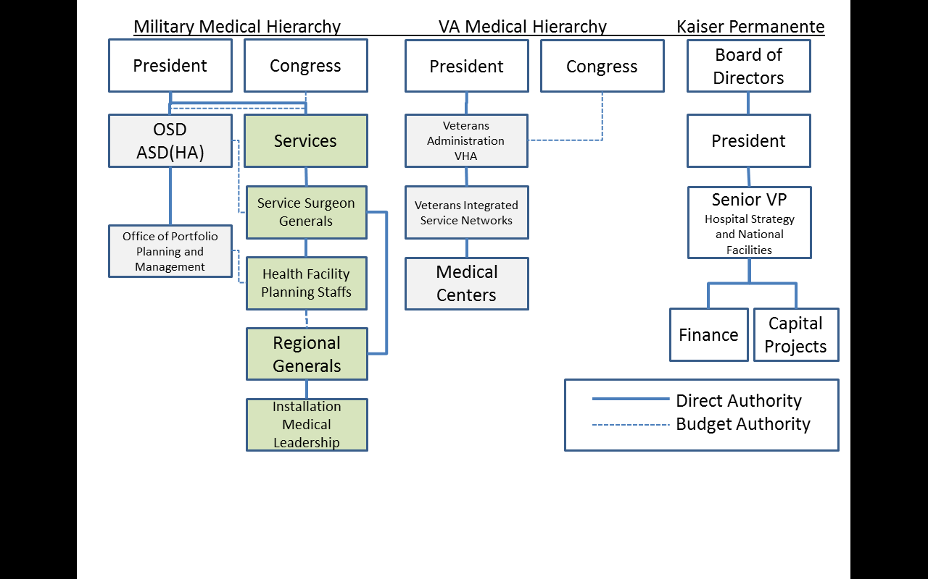

Figure , Comparable Organization Decision Making Structures.

Competing mission priorities occur because the service surgeon generals are subordinate to the service specific chief of staff who themselves focus on the missions of their respective service. The ASD (HA) is focused on military healthcare as whole which the service chiefs often view as sort of an afterthought. This creates a working partnership between the ASD (HA) and the service surgeon generals which allows for sort of a committee approach to solving health care issues. The gathering of the ASD (HA) and the service surgeon generals is called the Senior Military Medical Advisory Committee (SMMAC). Since the ASD (HA) holds the purse, he uses a staff group known as the Office of Portfolio Planning and Management, which organizes the collaboration with and among the service health facility planning management agencies, for the purpose of gaining consensus as to which Military Medical projects should be funded. The planning management agencies collect, organize, and validate the proposed project lists that are forwarded from the regions and installations. Organization healthcare focus can be demonstrated by reviewing overall percentages of budgets that are allocated to medical related activities. The following is a comparison of medical budgets by percentage that is allocated to healthcare.

* Department of Defense, $50.7 billion dollars in 2011 was allocated to military healthcare; the MHS comprised only nine percent of DoD expenditures[5].
* Department of Veterans Affairs, $51 billion dollars in 2011 was allocated to the VHA for healthcare; the VHA comprises 91 percent of the VA’s expenditures[6].
* Kaiser Permanente, a large Health Maintenance Organization (HMO), allocates 100% of its $40 billion dollar annual budget to healthcare. $40 billion dollars is what is reported in Kaiser Permanente’s 2006 financial report[7].

Understanding the MHS and inter-governmental relationships associated with capital investment decision making is critical to funding process recommendations and may lead to cost saving which could be invested in additional MILCON. Considering the unique governance structure of the MHS and the sensitive nature of public opinion all recommendations should be made with an eye to swift decision making and cost savings.

**Military Health Facility Capital Investment Planning Process**

Military Health Facility Capital Investment Planning is the process of developing a MILCON requirements list, analyzing those requirements to determine highest priorities, and presenting those priorities for inclusion in the President’s budget. The Sequential Military Capital Investment Planning Process chart is a representation of the process to be discussed through most of the next three sections of this project, including Planning, Army Scoring and MHS Scoring.

The end state of the entire process from MILCON requirements generation to the results of the Capital Investment Decision Model process is to generate a prioritized list of projects for inclusion in the President’s Budget. Those projects selected for inclusion in the President’s budget, are reviewed by Congress for approval in some form of legislation and returned to the President and signed into law.

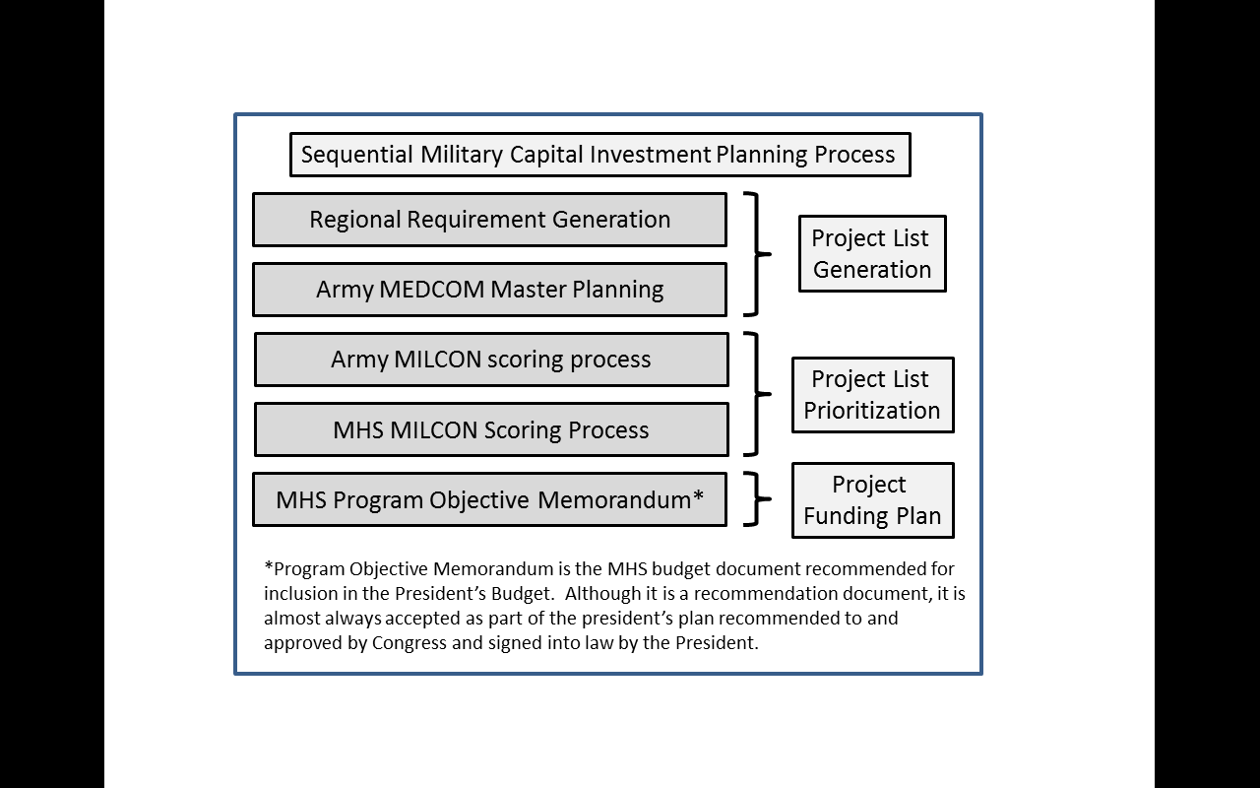

Figure , Sequential Military Capital Investment Planning Process, developed to explain the funding decision process.

The next three sections will discuss in detail the planning and prioritization process.

**Planning:**

The planning process has changed dramatically since the late 2000s. The Base realignment and closure (BRAC) legislation and the negative news articles related to the 2007 Walter Reed incident brought attention to the need for modernizing the military’s health facilities. The events were useful driving the MHS to perfecting a new comprehensive MHS project selection process which has contributed greatly to the funding of projects that support the greatest number of military personnel and correct the oldest elements of the services’ medical infrastructure. What follows is a concise review of medical facility planning history, an explanation of the current planning process, and discussion of the CSA imperatives linked to the funding and analysis of Capital Investment Proposals.

**History:**

Historically, medical MILCON planning was less expensive than the current fiscal climate because the services required no contracted help in the form of professional design services during the requirements generation phase. Before 2007 few projects were proposed and researched to the extent currently required because the funding levels were low and predictable. The services came to expect the MHS to evenly distribute the approximate $200 million dollars a year among each of the three services medical MILCON budgets. Depending on the fiscal year, any of the services could freely plan their slice of the MILCON budget, with only oversight at the service surgeon general level. This enabled a lower level of detail and study for proceeding with Design Bid Build (DBB) MILCON planning. Less intensive analysis translated into lower planning costs. Professional medical planning services were not required because the medical regions could provide data to the satisfaction of the service’s planning teams. Planning teams were then able to conduct analysis and complete the DD form 1391 construction requirements document. See Appendix A, DD form 1391 Fort Irwin, California; Hospital Replacement.

The assumption was made at the MHS level before 2007 that the services were the best at determining where capital investment dollars could be spent. The even distribution of medical MILCON funding was desirable in that the services had more influence in the decision making process, but the Army informally complained annually to the Office of Portfolio Planning and Management about receiving an unjustly small share of the budget. Army medical planners believed the equal sharing of MHS budget resources supported recapitalization better for the other services, since they had smaller building inventories. Equal funding and smaller inventory enabled the Navy and Air Force to have what often seemed like better facilities than the Army, but the equal distribution of MILCON resources did not match service work loads and building inventories. The Army supported approximately 45% [8]of all patient care, owned the majority of building square footage, and were responsible for all veterinary care and nearly all military laboratory research. The Army also had the primary role in treating returning wounded soldiers because it was the largest service in terms of personnel, it was the most engaged in the wars on terror and because Walter Reed Army Medical Center was the primary recovery facility for all seriously wounded service personnel returning directly from the battle field, including those from the other services. Since the 2011 BRAC closure of the Walter Reed Army Medical Center, all seriously wounded non-burn patients are treated at the modernized Navy Hospital in Bethesda, Maryland, which has been renamed Walter Reed Military Medical Center. Serious burn recovery patients are treated in the Army Medical Center in San Antonio, Texas, while short term recovery is managed at the service member’s home station medical facility.

After the Walter Reed incident, the MHS came under pressure to improve the military medical facilities and prevent any other potential for scandal. Fortunately, Congress passed nearly two billion dollars in new military medical construction by way of the 2008 Stimulus Act and the 2009 American Recovery and Reinvestment Act, of which most of the money was earmarked for Army projects.

The 2008 Stimulus fully funded two Army hospitals:

* Fort Benning, Georgia ($507M)[9]
* Fort Riley, Kansas ($404M)[10]

The 2009 ARRA legislation fully funded the $931M dollar Fort Hood hospital in Texas[11].

With the military medical needs remaining in the news, Congress became more interested in the medical MILCON budget process. This required the MHS to review all of the military medical projects together and fund the most urgent requirements first and not by even distribution of funds. The benefit was that the Army would have the opportunity to improve its infrastructure if it could prove that its hospitals and clinics were in greater need for investment than that of the other services. The risk was that every MHS capital investment dollar would require extensive analysis and that there would be a greater number of projects developed for submission. This increased the work load and required the hiring of professional medical planning services or design firms and forced the Army in house staffs to participate in much more active and expensive travel schedules; the consequence would be more money spent on planning than ever before. However, the main outcome was a nearly two year evolution in the developing of a Tri-Service MILCON selection process that culminated with intensive competition between the services for funding.

**Current Planning:**

Since 2007, military medical planning has become extremely intensive. The intensive adherence to the planning process, linking all projects to the Chief of Staff of the Army’s priorities, and the utilization of objective criteria serves to create a logical medical MILCON project list.

The process of creating a competitive project list begins with the generation of requirements. Regional Medical commands in the Army, and similar regional leadership divisions for the Navy and the Air Force determine with support from their subordinate installation medical units, create lists of requirements. These requirements are subject to regional analysis and an order of merit list is generated at the region level. The regional project list is designed to propose projects that assist in improving the weakest medical platform in terms of business model success within each command. Regional analysis is usually based upon patient care service metrics like thru put; wait times and treatment cost efficiency and typically has less to do with facility specific deficiencies like boiler replacements and fully sprinkled office spaces. The regional project lists are forwarded to the services’ health facility planning staffs, as the first step in building a service specific corporate project list.

The Army MEDCOM per direction of the Assistant Chief of Staff (Facilities) (ACSFAC) cross references the patient care centric data with known building inventory data, such as building age, recent capital investment, sustainment costs analysis, and also attempts to measure the patient care value per square foot for each proposal. Such a procedure is similar in the other services. Attempts are made to accept proposals from each region in order to evenly recapitalize the whole of Army medical infrastructure for reasons similar to the MHS attempt to evenly funding each of the services fairly. After the MEDCOM facility staffs review the entire list of project proposals, a manageable number of projects are selected for professional study by medically-focused design firms and military planning staffs.

Military facility planning expertise is usually drawn from handpicked military officers with expertise in the following disciplines:

* Medical Logistics Officers
* Professional Engineering or Architecture Education
* Healthcare Administration Education
* Nurse Corp Officers
* Medical Equipment Specialty Warrant Officers

The professional design teams and military staffs schedule site visits, conduct face to face staff interviews concerning local processes and patient demographics, and develop collaborative solutions.

An example of a collaborative solution might be the problem of an infection control issue in a surgical suite. The Nurse Corp officer would have expertise in medical treatment process and sterilization standards. The Engineer could develop a redesigned floor plan, based upon the nurse input, the technical expertise of the warrant officer and the sustainment knowledge of the logistics officer. The early design specifications would then be delivered to a design firm for enhanced development and comparison to industry standards. The collaborative effort might develop multiple options, which could be discussed with local leadership and a “best” solution would them be decided.

The out brief of each site visit includes a solution that is approved by the hospital commander which is pursued in the collaborative generation of a Capital Investment Proposal (CIP). The combining of data collection during an installation site visit and the corporate facility data culminate in the Master Planning Process.

The below diagram expresses the considerations associated with either a military Health Care or a Medical Research facility collaborative planning effort. The left and center columns with the headings of either Health Care Market Analysis and Research Market Analysis list analysis considerations for either type of facility site visit. Both types of planning visits require Data Collection, Demand Analysis, Planning Scenarios and Space forecasting. The right column lists requirements for both types of visits but relate directly with the condition of the building and the proposed location of the possible building project. The collected data is combined and alternatives are considered such as changes to operating procedures or purchased/contracted commercial support. If the alternative is assessed as less desirable than a capital investment then the solution is further developed and prepared for funding consideration.

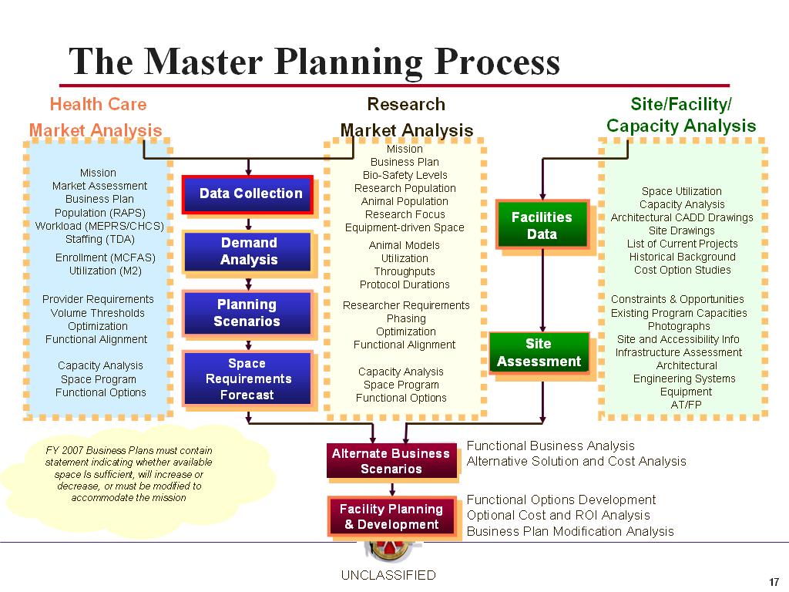

Figure , The Master Planning Process, developed by the Army MEDCOM PPD

**CSA imperatives:**

In conjunction with the Master Planning Process, it is vital to link project criteria to CSA imperatives to meet the intent of the Army mission and to prepare for unplanned funding opportunities like the 2009 ARRA or similar short term funding authorization by the line Army for medical MILCON. From 2007 until 2013, nearly $1.5 billion were authorized for acquisition of Army Medical MILCON from either Base Realignment and Closure (BRAC) or line Army as related to the CSA imperatives[12].

BRAC was a congressionally legislated study designed to cut un-necessary real property inventory among the services for the purpose of reducing annual sustainment costs. The culmination of the study directed the closure a several installations to include the Walter Reed Army Medical Center in Washington D.C. and ordered the relocating of its medical services to other medical installations in the National Capital Region (NCR). The Army benefited from BRAC with the funded acquisition of a $900 million dollar Fort Belvoir Hospital Replacement project located in the southern half of the NCR. Most of the other $600 million dollars programmed for medical MILCON from the line Army were associated with supporting the CSA’s imperatives[13].

The four CSA imperatives are the major points with in “The Army Plan” (TAP) and include the following:

* Sustain the force through recruiting and retention.
* Prepare troops for success in the current conflict.
* Reset the force to prepare for deployments and contingencies.
* Transform the Army[14].

TAP is a planning document used to guide the whole of the Army towards compliance with the Quadrennial Defense Review (QDR), which outlines DoD strategy and priorities associated with national threats and capability requirements. In the context of Medical MILCON, the fourth Army Imperative, “Transform the Army” was most important because of the dramatic changes in medical support requirements related to Grow the Force, Re-Stationing of combat and support units, Modularity and Global Defense Posture Realignment (GDPR), all of which were validated under the banner of Transformation.

Throughout the middle and late 2000s, Transformation became the critical medical planning consideration, because each military installation had been fitted with a determined medical capacity and product line. With the large migrations and addition of “Grow the Force” soldiers, some installations would suffer severely restricted access to care and readiness would be reduced if new facilities were not built. The following is a brief explanation of the increase of personnel and the associated migrations to different installation as relates to Transformation:

* Grow the Force mandated the Army grow from a standing personnel strength of 487K to nearly 550K with a temporarily increased end strength of 580K, which is supposed to have ended by 2012.

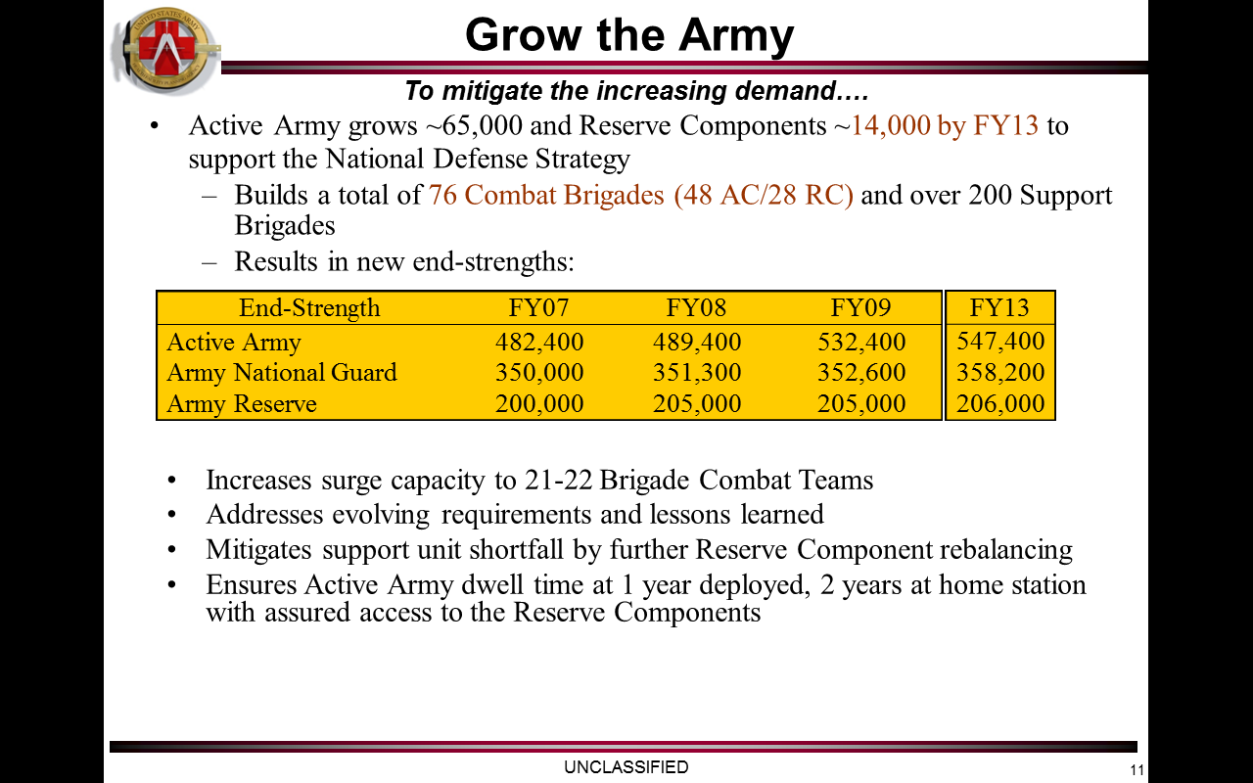

Figure , Army End-Strength Projections, based upon 2010 COP projections.

* Brigade Combat Team re-stationing efforts culminated with highest populations at Fort Bliss, Texas; White Sands Missile Range, New Mexico; Fort Carson, Colorado and Fort Stewart, Georgia. This was a shift of nearly 20K soldiers and nearly 60K family members.
* Combat Service/Combat Service Support unit population changes created re-stationing efforts which shifted approximately 20K soldiers to new military installations.
* Army Modular Force (AMF) was the redesign of the Army force structure for the purpose of creating smaller stand-alone brigade size formations that could accomplish tasks similar to that of the large Army division formations. The end state of this transformation would build a total of 76 Combat Brigades (48 AC/28 RC) and over 200 Support Brigades and shift soldier basing around the world.
* Global Defense Posture Realignment (GDPR) was designed to decrease the Army’s world-wide presence overseas. The end-state was to shift soldiers from forward deployed locations in South Korea and Germany back to installations within the continental United States.

In order to keep track of all of these changes the DoD created as staffing cell that specialized in the overall transformation. The Army’s Transformation project management staff created a useful product called the “Common Operating Picture” (COP).

The following is an example of the COP data base for a generic military installation:

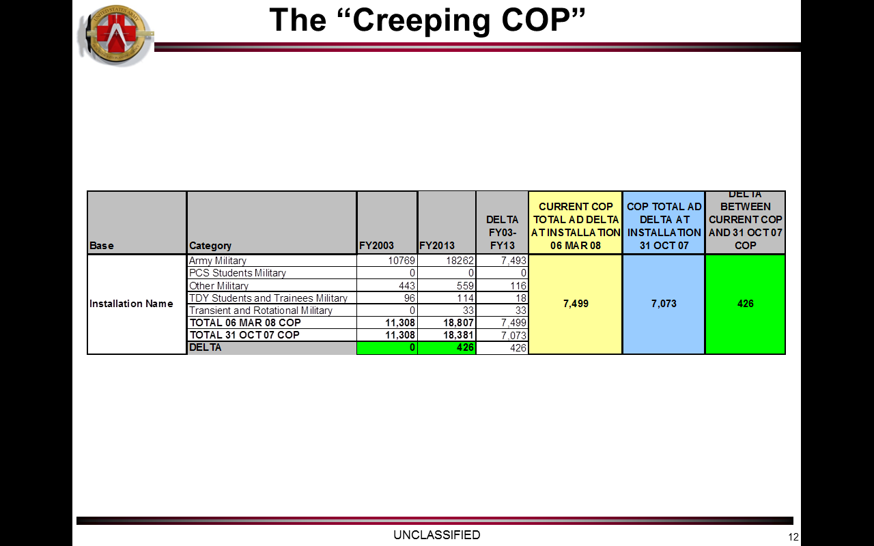

Figure , Common Operating Picture Example, provided by the Army MEDCOM Transformation.

The COP was made available to all decision making “groups,” for the purpose of validating planning requirements associated with the movement of personnel. The information extracted from the COP became vital for justifying MILCON proposals, because the population delta could be compared with capacity templates. These population template comparisons were usually the initial clue that an installation required a medical planning assessment. Before the templates, medical assessments were scheduled at a minimum of once every five years for every installation and sometimes on a case by case basis if required by a medical region. The COP enabled the targeting of high priority assessments and enabled world-wide overview of beneficiary shifts.

The following is an example of a capacity template:



Figure , Example Capacity Template, developed by the Army MEDCOM PPD

Changes in soldier populations required adjustments to many of the Army’s medical facilities. COP changes supported the generation of requirements associated with medical facilities. The database enabled decisions relating to primary verses specialty care construction to population, workload, provider analysis, and space utilization. The following is a brief description of the four components of analysis:

* Population Analysis defines the population using MHS services and determines to the extent to which primary verses specialty care is relied upon.
* Workload Analysis contrasts historical utilization records with normal workload attributed to the population.
* Provider Analysis determines the number and composition of medical providers and recommends the optimal building configurations.
* Space Analysis combines workload and staffing forecasts with identified required spaces. This analysis utilizes defining characteristics to determine the sizing of rooms based upon the medical purpose.

Since the MHS recognized that greater emphasis on capital investment was necessary, project planning has changed significantly from an internal service-based system to a more scientifically developed and validated process. Simple low cost planning has been transformed into complex costly decision making that is designed to link corporate imperatives to justifiable investments. What used to be the professional recommendation of the senior medical facilities officer based upon subjective evidence is now a numerically based and comprehensively packaged decision process both at the Army level and for the MHS.

**Army Scoring:**

A significant factor in the added complexity of the MHS capital investment decision making process is because there are two sets of project scoring. The first assessment is by using the respective service’s score card and then by screening each project according to MHS criteria for comparison among all of the Army, Air Force and Navy proposals. The value of the two-step scoring process for Army MEDCOM is that consideration is given to CSA imperatives and it is possible for the service to gain a higher percentage of the MHS budget because funding selection is merit based and not restricted to a one third share. Another part of the importance of the two step scoring process is that each of the three services score their own proposals which logically determines their own top three priority projects. The services’ top three projects are important because they are given a scoring advantage on the MHS selection process. The MEDCOM score card supports the Army’s prioritization list (1-N), which also allows a review of all of its projects, and determines if some important projects require more planning resources. A final benefit of the 2010 Army scoring process was that it was predictive of which projects were most likely to score well with MHS criteria. What follows is a review of the Army’s 12 scoring criteria, the scoring process and the how the scores are used:

**Army MEDCOM’s Project Score Card:**

The MEDCOM capital investment score card is used to rank all of the medical MILCON project proposals for use in a given funding cycle. MEDCOM facility planners developed the score card concurrently as the MHS capital investment selection process evolved. The idea behind the card was to empirically justify those project characteristics that were thought to be important to the Army Surgeon General. The result was the creation of 12 criteria used for proposal ranking and designed to focus on characteristics that support the medical mission, facility centric requirements, or a balance of both. The following is a brief description of the 12 criteria:

1. **Region:** The first criterion is called the “Region” metric and is based on the Regional Medical Commands’ priority of their project proposal as ranked among all of its regional projects. Since every region provides a prioritized project list to the MEDCOM, the higher priority valued projects of each region will compete better among the entire MEDCOM list. This balances the distribution of region submissions on the 1-N list so that MHS funding may evenly consider support for the entire MEDCOM real property inventory. Equal and objective funding consideration among the regions was desirable even though medical needs were not necessarily the same. A secondary benefit of the region criterion is that it somewhat neutralized installation favoritism.
2. **Mission 1:** The second metric is called “Mission 1” and is intended as the first of three mission specific metrics. The definition of the Mission 1 metric is to promote, sustain and enhance the active duty health requirements for the installation population based upon the purpose of the proposal. Scores are based upon the population size of active duty soldiers at a given installation. The benefit of this metric is that it supports the needs of the greatest number of soldiers; however, the problem is that this metric creates a consistent advantage for the largest installations.
3. **Mission 2:** The “Mission 2” criterion is based upon purely health care support services and is scored by counting the number of product lines that a project proposal is intended to support. The intent is to enhance medically critical service lines. This criterion is supposed to prefer locations with diverse medical treatment capabilities. The advantage is that proposals with positive impacts on the greatest number of services will support the greatest number of patients; however, the unfortunate consequence is that hospitals generally have greater diversity of care options and would typically score higher because of this advantage.
4. **Mission 3:** “Mission 3” is based upon total enrollment numbers associated with a location. Enrollment includes active duty soldiers, their immediate family members, and retirees who are eligible for treatment. Like the other mission criteria, the idea is to provide the greatest good for the most people. This would create an advantage for larger installations located in larger communities where retirees would be more likely to live. The disadvantage is that remote locations where medical services are already scarce in the local community would score lower even though the need might be argued as greater.
5. **Remote Network:** In order to mitigate the advantage that is often associated with installations located within large communities, which therefore usually have specialty medical services that can be purchased off the network, the “Remote Network” criterion was developed. This point enables the grading of proposals based upon how remote an installation is from an advantageous medical network. The advantage is that hospitals with few referral options should have some preference for capital investment.

1. **Life and Patient Safety:** This criterion supports projects that improve the safety of the medical platform. The idea is to support investments that elevate patient safety codes, such as fire protection, to current published standards. Seismic protection and anti-terrorism/force protection standards are also important considerations in this criterion.
2. **Facility Age:** Increased MHS emphasis in medical MILCON capital investment enabled the goal of trying to reduce the average life span of military medical facilities down from 75[15] years to 31. High-scoring “facility age” proposals are desirable so as to meet the MHS life span goals of Army hospitals and clinics. This also enables providers to work in modern facilities and patients are generally better able to heal while under treatment in “evidence-based designed” buildings[16]. In many cases, a project that modernizes an old building results in what amounts to a reduced life span and is equally desirable to that of a proposal that requests a complete replacement. A disadvantage to this criterion is that it generally favors complete replacements over modernization proposals, which may potentially lead to higher costs and result in a smaller number of funded projects.
3. **Facility Condition:** The facility condition index is an analytical assessment of the proposed building projects. The intent is to support investments in buildings that are in the worst shape. The higher the Quality (Q) rating the worse the buildings assessment.
4. **Capacity Concerns:** This is defined as fixing problems associated with changes in beneficiary population and mission. The concern over the medical capacity is directly related to the CSA’s Transformation imperative. Although many of the most significant medical requirements were supported with $600 million dollars in “line Army” funding or $2 billion dollars congressional legislation, not all capacity requirements are supported. This criterion benefits some of the lesser used, but still necessary, MHS requirements, such as Preventative Medicine and Veterinary services.
5. **Demand Imbalance:** In some cases, medical facilities are not sized according to current demand. Overtime, the use of facilities, and their medical support capacity change from what was intended to what is now reality. Often buildings, especially those associated with the recruit training mission or dental clinics, are used at a higher level than what is considered a normal standard of care. This criterion is used to fix short falls in the number of exam, treatment, and labor and delivery rooms. The intent is to level and balance the care offered across the entire Army medical system.
6. **AMEDD Utilization:** Army Medical Department (AMEDD) Utilization is intended to support the resources, meaning space allocated, for specific services by improving colocation of complementary services which support staff efficiency. To illustrate the intent, consider an investment that locates radiology near the orthopedic department so that a soldier that has a broken leg doesn’t have to hop the entire length of the hospital for an x-ray. The advantage is that projects which score well with AMEDD Utilization will support cost savings in time and healing in ways that are difficult to calculate.
7. **VA Collaboration:** This criterion is used to grade based upon the extent to which the proposal supports medical partnerships with the Department of Veterans Affairs. VA partnerships are desirable for cost and resource sharing. Additionally, it is desirable for Army medical providers to treat VA beneficiaries for the purpose of increasing patient diversity and maintaining physician skills. This is also an area of congressional interest and directly matches the MHS score card criterion, “Collaborative Synergies.”

In addition to the 12 Criteria, the Army score card is designed to easily adjust weighting so as to focus on a set of priorities. The idea is that depending upon the decision maker, probably the Army Surgeon General, the weights can be set to support a mission, facility restoration or balanced distribution of weights. The Mission emphasis bulks up the scoring weights for the three mission criteria. The Facility weighting uses the facility condition index, the age, capacity and demand imbalance as greater emphasis. The balanced or equal weight column is intended as a middle ground between mission and facility centric decision making. The application was overall useful for determining Army priorities because the results were accepted by the Army Surgeon.

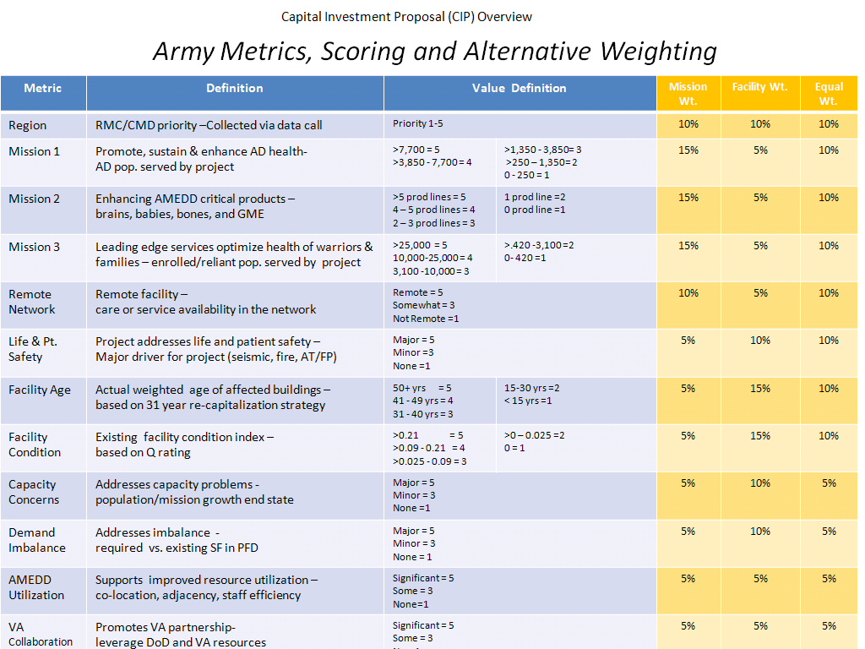

Figure , Army Metrics, Scoring and Alternative Weighting, developed by the Army MEDCOM PPD[17]

The 12 criteria were designed as an empirical expression of what was believed to be medically important to the Army Surgeon General. The process was successfully presented to LTG Schoolmaker, Army Surgeon General, and validated as an appropriate decision making tool in an April 2010 facility prioritization decision briefing.

**Army Medical MILCON Scoring Process:**

After the generation of the project list, the entire planning team gathers for an objective review. Lead by the Director of the Planning and Programming Division, the group is requested and the gathering is funded as part of the PPD budget. The composition of the planning team includes the Health Facility Planning Agency and ACSFAC military staff, Army Civilians and all of the architectural and design team professionals who have worked on any number of the projects. The group name for the gathering is called “Team Army” and it meets quarterly in Washington D.C. for professional development training and project collaboration. Team Army is used to grade the projects because they have the most familiarity with the material, can answer questions and also leverage a lot of knowledge in the grading of the project list.

The scoring day is when Team Army gathers with the goal of completing a review of the criteria, the proposals and the results. The first activity is a review and explanation of all of the scoring criteria. Purpose and logic are explained for each criterion by either the Director of the PPD or a designated representative. After the entire group is familiar with the scoring criteria, project by project review is conducted. The review explains the history, the need and the urgency as well as specific questions that link directly to the 12 criteria points. Each review is concluded with a complete scoring endorsed by the entire group. After all of the proposals are scored, questions are asked such as “if we score this project like this then why didn’t we score that project the same way?” This final review attempts to balance the scoring of the entire proposal list. Since the input is automated, the results can be immediately presented after all of the scoring is complete. Then a final discussion can take place that determines the logic of whether the data should favor mission, facility or a balanced weighting.

The benefit is that medical construction experts can provide reasons for a particular type of weighting; however, the problem with this type of group input is that discussion points can be somewhat self-serving among the design teams. For instance, if a project is selected as the top priority and then it is used and competes well in the MHS process, then more work could be billed for future refinements and tailoring to the MHS scorecard. Additionally, a room full of competing design firms, would each like to claim the largest number of high priority projects as a way to advertise the quality of their work and there by show the PPD staff and those responsible for hiring that they do the best work. However the gathering of expertise has been valued above the risk of design firm competition.

**Army Medical MILCON Scoring Purpose:**

The most important outcome of the Army medical MILCON scoring process is to get the Surgeon General (TSG)’s buy-in of the selection method and acceptance of the 1-N list. TSG’s accepting of the 1-N list is also the endorsement of the top three Army projects which have direct scoring application to the MHS score card. Although desirable for the staff to know the Surgeon General’s weighting preferences it is difficult to gain scheduled discussion time and usually preference questions are left up to the general staff and only confirmed in the context of the decision briefing. In the briefing the weighting considerations are presented as options and the Surgeon General ultimately selects the preferred option or directs another course of action. The logic provided by Team Army is used but ultimately the decision rests with the Surgeon General. In the case of the 2010 Army 1-N list generated and approval by the Surgeon General, mission weighting was selected as the primary factor and resulted in four projects considered for the Army’s top three MHS priorities:

* Fort Shafter, Hawaii Hospital Additional Alteration project for $1.4 billion dollars.
* Fort Irwin, California Hospital Replacement Project for approximately $300 million dollars.
* Fort Knox, Kentucky Hospital Replacement Project for approximately $480 million dollars.
* Aberdeen Proving Ground, Replacement Laboratory for $173 million dollars[18].

After a 20 minute discussion with the LTG Schoolmaker, it was determined that the Fort Shafter project should be disqualified because it was too expensive to ever get funded under the current MHS fiscal planning assumptions. The outcome of the meeting resulted in the Fort Irwin Hospital Replacement project becoming the top Army submission, followed by Fort Knox Hospital and Aberdeen Proving Ground Laboratory as the second and third priorities. The Fort Shafter proposal was ordered back to the drawing board for further study and development.

All of the projects on the Army 1-N list were approved for packaging and consideration in the MHS selection process with the exception of the Fort Shafter Project on Hawaii. Proposal components are discussed in more detail in the next section. The outcome of the Army scoring process resulted in solid staff analysis of each project submission and secured the Surgeon General’s endorsement of the Army’s top three medical MILCON priorities. The Surgeon General’s endorsement was important because it was a required factor in the MHS MILCON selection process called the Capital Investment Decision Model (CIDM), which is described in the next section.

**MHS Scoring: Capital Investment Decision Model**

The Second part of MHS decision making process is based upon a database application called the Capital Investment Decision Model. Though CIDM actually is the acronym for the software system it has come to have a short hand meaning for the combined services’ MHS capital investment process, which includes data validation, data loading and a final evaluation by Tri-Service medical representatives assigned to the Capital Investment Review Board (CIRB). To prepare and establish a tri-service rank ordering of military medical MILCON proposals, the Office of Portfolio Planning and Management, which is the subordinate agency to the ASD(HA), organizes the Pre-CIRB Validation Template (PCVT) committee and associated meetings, operates the CIDM score card program and facilitates the CIRB. These three components are vital for successful MHS capital investment decision making and are discussed in more detail below.

**Pre-CIRB Validation Template:**

The Pre-CIRB Validation Template is the criteria required for a Capital Investment Proposal (CIP) to qualify for inclusion in the CIDM. It also has come to have another meaning, which is the gathering of the PCVT committee that is comprised of Army, Navy and Air Force representatives and members of the Office of Portfolio Planning and Management to validate CIP for submissions to the CIDM. The validation is to assure the consistency of planning facts and assumptions and to check if all required documentation is complete so as to confirm a project’s readiness for CIP submission.

The required documentation includes the following:

* 3 page CIP Template: includes the required data fields directly associated with the CIDM.
* Department Level Program for Design: The early design concept.
* Characteristics document (# ORs, # Beds, etc.).
* DD form 1391 – Project Programming Document – Front Page.
* Quad Chart: A single page representation of the project. Below is the Fort Irwin CIP Quad Chart.

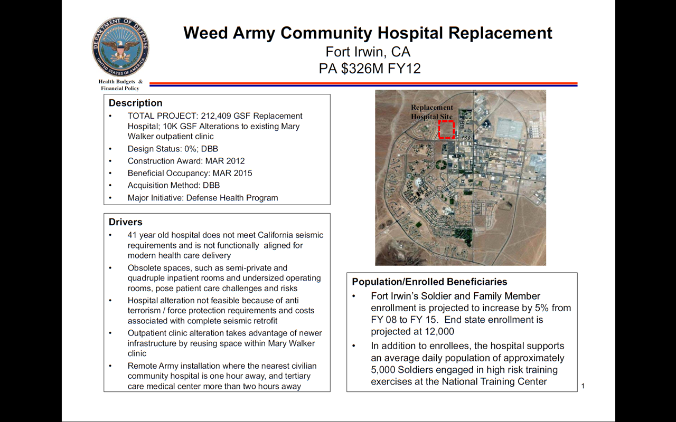

Figure , Fort Irwin CIP Quad Chart

The above quad chart was used to represent of the Weed Army Community Hospital Replacement CIDM proposal. The information presented in this slide is specific to spring 2010 expectations related to CIDM and since that time adjustments to the program amounts and construction schedule have been made. The quad chart, like the one above, is designed to present the maximum information possible in a single page.

The PCVT documentation is required so that all proposals possess an equal level of detail and are immediately ready for initiation of design team solicitation, in case the project is selected for funding in an early budget year. In 2010, 76 CIPs were developed for the CIDM process, which required four PCVT committee meeting days to complete the review of every project. When all of the CIPs were finally graded by the tri-service PCVT team and confirmed as valid and complete, the projects were imported into the CIDM program.

**Capital Investment Decision Model:**

The CIDM score card is similar to the Army score card in the nature of the criteria but different in actual definition and evaluation. Eight grading factors are used under the headings listed in the Sub-Criteria column instead of the twelve criteria used in the Army score card. The following is a list of the grading factors, the purpose, and whether the grades are based upon PCVT validated data or if the grade is subjectively assigned by the CIRB:

* Mission/Scope Change: This information is used to determine how much of a change to the mission has occurred to justify a Capital Investment. The grade is subjective and is determined by CIRB.
* Service Priorities: This is the endorsement of the service’s top three projects. Only three projects from each service can score. This grade is subjective in that the service surgeon general determines his or her project’s priority and in the case of the Army, significant analysis and staff work is conducted before a recommendation is presented to the Surgeon General. Air Force conducts a similar level of analysis and the Navy has historically been less scientific in determining their priorities.
* Location Constraints: This is a subjective criterion based upon the judgment of the CIRB. The intent is to grade projects in the context of the local need compared against the opportunity to use local community healthcare services.
* Weighted Square Foot Age Improvement: This criterion is based upon the PCVT committee’s agreed modernization factor that a proposal supports. The idea is that an investment in an existing medical platform can reduce the overall average age of the facility. As an example, suppose a 60 year-old hospital is replaced with a completely new facility; the average age improvement of the facility would be a reduction of 60 years.
* Percentage Reduction in Square Footage: It costs money to maintain a building and MHS infrastructure sustainment budgets are based upon the square footage of medical facilities, so it is an advantage to reduce the overall size of MHS real property. CIPs are graded during the PCVT meetings on how much smaller the project will make the existing infrastructure. The greater reduction of square footage, the more desirable for the MHS and the better the score.
* Collaborative Synergies: This CIDM sub-criterion is similar to the Army’s VA collaboration metric. It is primarily designed to support inter-governmental cooperation for the purpose of medical cost sharing which is often possible with the VHA, and could be possible with the Coast Guard or the Uniformed Public Health Service. The collaborative synergies grading is determined during the PCVT committee meetings.
* Life, Health, Safety Threatening Deficiency: This sub-criterion is a binary grade determined during the PCVT committee meeting and results in either a yes or no. The intent is to grade CIPs against the severity of expensive structural dangers. During the 2010 CIDM process, only four projects were graded with enough severity to merit score out of the 76 considered projects; Fort Irwin’s hospital replacement project was one of the four.
* Qualitative Assessment: The CIRB subjectively determines the grade based upon the provided materials. An equal number of quartile grades must be selected; for example, if there are 8 CIPs, only two CIPS can achieve a score of 1, two CIPS can score as 2, and so on.

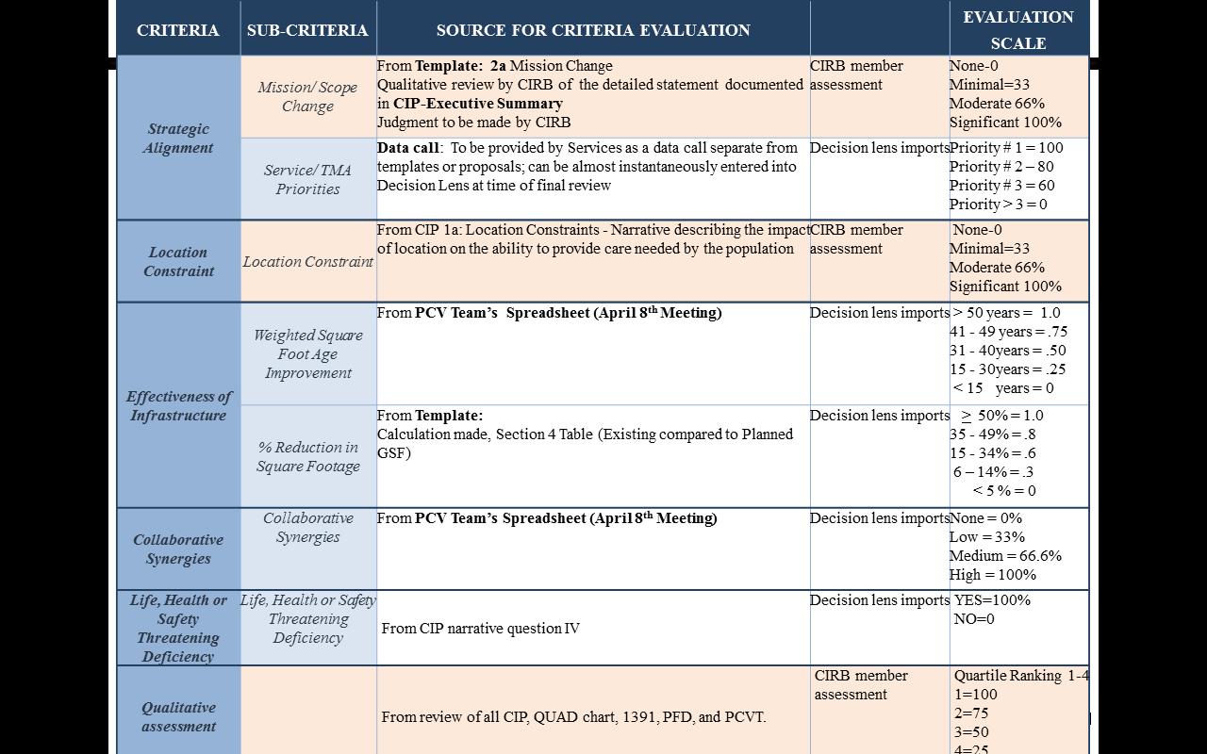

Figure , MHS Metrics and Scoring Card, Jointly developed by the Tri-Service Facilities community for the CIDM[19]

Of the eight graded criteria, four are subjective in that they depend on the scores determined by either the CIRB or the service surgeon generals and four criteria are based upon actual data analysis that has been validated by the PCVT.

**Capital Investment Review Board:**

After the projects are selected, the data is validated by the PCVT committee, transferred into the CIDM using a data import program called “Decision lens,” and the CIRB is assembled for the final grading of the CIPs. The CIRB is composed of three senior officers from each service and three civilian representatives from the Office of Portfolio Planning and Management. The services are recommended to provide at least one physician, one facility management expert and one representative with either a resource management or medical operations background; however, the services are completely free to select their own team. The Office of Portfolio Planning and Management also provide three representatives to the CIRB.

The CIRB process begins when the twelve representatives are given a week to review all of the CIPs on their own time. During their review week, they are encouraged to email questions to the PCVT committee. At the close of the week-long review, the CIRB members attend a committee “lock in” so that they are not distracted during the grading process. During the lock in, they are officially briefed about every project, the group comes to consensus on the meaning of the criteria and then the representatives evaluate the proposals. The results are tabulated and analyzed by the Office of Portfolio Planning and Management and if there are no issues, the MHS 1-N list is released to the services for review and acceptance by members of the SMMAC.

The outcome of the CIDM process is a detailed and layered analysis that combines equitable MHS resource sharing with service priorities. The final product of the planning and scoring processes is a rank ordered project list called the 1 to N.

**After the Capital Investment Decision Model:**

After the CIDM, the process culminates with the official MHS prioritized ranking of all three of the service’s MILCON proposals which are developed to a point in which they are immediately ready for funding. The “shovel ready” 1 to N list is then used to fill in the budgetary years associated with medical MILCON and the process of project acquisition is initiated as appropriate to the corresponding fiscal years.

From the point of the generation of the MHS 1 to N list, the following activities must be accomplished to confirm the project’s funding and projected funding year:

* The ASD (HA) as well as the Service Surgeon Generals must agree with the list in the SMMAC. Since each of the three services have had their respective staffs working in the joint selection process it is unlikely that the results would be overruled.
* The ASD (HA) uses the 1 to N list to build its Program Objective Memorandum, which is essentially a memorandum directing the medical MILCON budget allocations for inclusion in the DoD defense budget.
* The DoD budget is included in the President’s Budget, which is a funding proposal for the whole of the entire United States Government.
* The President’s Budget is published and submitted to congress for passage as a bill called the Defense Authorization Act. Congress usually directs a few changes to the President’s proposal, but there are no historical examples of medical MILCON changes to the POM.
* The Defense Authorization Act is then returned to the President for signature and passage into law. Once the president signs the law, the medical MILCON budget cannot be changed except by either a new law or by an executive order.

From the ASD (HA) and Services’ perspective, there is only minor risk to the project list once the medical MILCON POM is published. At the same time as the SMMAC and the publishing of the POM, the initial project reviews begin for the earliest project starts which must be awarded approximately 24 months after the CIDM results.

**The Outcome of the 2010 Capital Investment Decision Model:**

The 2010 MHS selection process resulted in the Fort Irwin Hospital Replacement project becoming the top medical MILCON investment requirement, which also meant the project would begin construction in late fiscal year 2012. However, the Fort Irwin Hospital replacement project had one significant risk to overcome. At an estimated cost of more than $300 million dollars, the new hospital was potentially too expensive to fund in a single fiscal year. Fortunately, the SMMAC reviewed the CIDM results and agreed to allow full project funding in fiscal year 2012.

It was important to get the full project funded in a single year because White House guidance to the services required full and complete funding of all MILCON with in a single year. No incremental or phased funding was authorized for any project, even large projects. In the end, the project was authorized and fully funded.

However, before the president’s budget was presented to congress, the ASD (HA) submitted the project for funding through the 2009 American Recovery and Reinvestment Act. The initial writing of the bill allowed the services to determine which medical MILCON project to fund, which resulted in the full funding of the Fort Hood Hospital replacement project. However, for reasons not clear, money was made available to also fund the 2012 Fort Irwin project with ARRA money, two years later. At this writing, I cannot get an answer as to why this was changed. The following are theories as to why the funding source changed:

* The Medical MILCON projects previously listed for ARRA are anticipated to cost less than expected.
* The White House requested a green energy project.
* Money allocated for ARRA was not yet fully spent and the Fort Irwin project was probably the right size and closest to “shovel ready” for funding.

From the time the Fort Irwin Army Community Hospital was selected for FY12 funding, the Army Health Facility Planning Agency and the engineers in the Office of Planning and Portfolio Management immediately rescreened the DD form 1391 project document to confirm planning assumptions. The following is a summary of the Fort Irwin Project and a short review of unique discussion points to the DD form 1391. The DD form 1391 short form is available in appendix A.

**Fort Irwin Hospital Replacement Project:**

The intent of the Fort Irwin Medical MILCON is to construct a replacement hospital that will provide new tertiary level care, emergency medicine, and clinical support activities and will include the renovation of the existing troop medical clinic. Specified and vacated medical buildings will be demolished or transferred to installation custody for reuse. The overall project will include utilities, site improvements, new parking access, and roads as well as environmental and anti-terrorism protective measures.

Fort Irwin requires a multifunctional medical facility to provide and manage the healthcare of remotely posted soldiers and their families and to enable immediate stabilization care associated with labor and delivery and for battle field injuries associated with the National Training Center (NTC) mission. The NTC is the Army’s primary desert warfare training center with emphasis on armored combat. On post emergency medical support is required because the realistic combat simulations frequently generate casualties.

The project will replace a 40 year-old station hospital and 5 outdated temporary or prefabricated buildings associated with the disjointed medical campus because the old medical buildings have exceeded their collective life cycles. This will clear the medical campus of problems associated with ineffective medical delivery standards and noncompliance with current State of California building codes that specify seismic standards. Analysis leading to the replacement decision was conducted during a 2009 Health Care Requirement Analysis (HCRA). The study reviewed population and workload projections as well as staffing capacities available at the Fort Irwin Army Installation which resulted in the hospital Capital investment proposal. The primary criteria factors in recommending a new hospital included Demographics, Staffing Forecast, Existing Conditions and Facility Scope and space requirements.

Demographics:

Weed Army Community Hospital on Fort Irwin provides general and limited specialty care for inpatients and outpatients. Using the Managed Care Forecasting and Analysis System (MCFAS), which produces population projections based upon zip code demographics, the following is projected through fiscal year (FY) 2013:

Active Duty: 5,227 37%

Active Duty Family Members: 6,912 49%

Retirees/ Retiree Family Members: 1,489 10%

R65+/ Medicare Eligible: 608 4%

Military Community Population: 14,235[20]

Monthly Rotation of NTC soldiers: 5,000

Total number of medically supported personnel 19,235

Staffing Forecast:

Staffing analyses of work time rates are linked to specific medical specialties recorded from historic service levels. The following are applicable to Fort Irwin’s current level of service:

• Available clinic hours per day: 6 to 7 hours

• Available clinic days per week: 3 to 5 days

• Available procedure days per week: .5 to 2 days

• Available weeks per year: 41.2 weeks

• Average visits per hour: 1 to 3 visits

• Average provider visits per year: 1,236 to 4,326[21]

Based upon current support requirements, the staffing forecast recommends 20 primary care providers and 19 specialty care physicians to sustain appropriate and projected MTF workload forecast.

Existing Conditions and Facility Scope:

The current one story main hospital building is composed of a concrete and steel support structure with outer facades that are largely concrete cast panels. The hospital underwent incremental additions during its 40 years of operation and over that time the configuration has become haphazard. The medical facility uses service and storage spaces located in 5 outdated exterior wood modular structures. The other primary medical support buildings are the dental clinic and the Ambulatory Care Center (ACC). The dental clinic building is composed of a masonry and precast concrete clad steel structure. It is organized with a large central dental treatment bay and is flanked by two support service areas. The ACC building is similar in design and construction to the dental clinic.

The dry climate has preserved all of the medical structures and the entire medical campus is considered in excellent condition with the exception of mechanical systems in the main hospital and dental clinic. The buildings and grounds are very well maintained. The entire campus is located in proximity to the neighboring parade field. Travel distance between linked services across the seven building campus is un-desirable and sometimes requires the driving of patients from one building to another. Additionally, the emergency entrance and the main entrance of the hospital building are confusing and often lead patients and visitors into staff only areas which routinely risk patient privacy and infection. The disjointed services and nonsensical patient flow are throughout the main hospital and detract from generally accepted standards of care[22].

Space Requirements:

The defining space characteristics are the understood dimensional requirement used to support modern healthcare practices. For example, an exam room is required to be constructed to an appropriately rectangular dimension with a square footage of not less than 110 square feet, so that appropriate space is available for the proper placement of furniture, automation, and technical assessment support equipment in addition to space for patient privacy. The Fort Irwin study concludes that 9 inpatient beds are required and should be outfitted to support five Medical/Surgical beds and 4 Obstetrics beds with single patient occupancy. Outpatient space requirements demonstrate a need for 64 total exam room spaces[23].

At first glance the service requirements seem excessive for a 15 thousand beneficiary population; however, an assessment of the available referral services, support the sustained inpatient requirements. The nearest medical facility to the Fort Irwin Community is more than 45 miles away and its services do not support a higher level of care than what is currently available on post. Considering the risks associated with the Army’s primary armored desert warfare center and the consistently high casualty rate associated with the realistic training, a military hospital is required.

Fort Irwin’s DD form 1391 adjustments:

Most of the requirements listed in the DD form 1391 are standard planning assumptions which list and justify the complete and projected cost of the planned building. Unlike many military structures, medical projects are always unique and rarely are any two military hospitals alike. Part of what makes the Fort Irwin project interesting is the fact of its remote desert location. The following discussion will focus on four significant discussion points related to the Fort Irwin CIP which include the determination to use the Design Bid Build acquisition strategy, the building of a photo voltaic power generation capability, evidence based design and the adjusted construction cost of $274 million from $326 million.

**Acquisition Method:**

Upon selection of the Fort Irwin Project, the HFPA engineering team decided it wanted to execute the project using the Design Build acquisition strategy even though the project had been selected in the CIDM as a Design Bid Build project. The advantage to the HFPA engineering staff would be a savings in time and simplicity in initiating the project. The disadvantage is that a $300 million dollar hospital is considered a large and complex project. Prior to the Fort Irwin project, only one other hospital has been attempted using Design Build. The only Design Build hospital project so far started by the military has been the $900 million dollar project located at Fort Hood, Texas also ARRA09 funded. So it was possible to use Design Build was on the Fort Irwin project. The following are the acquisition options that have been used for medical projects.

* Design Bid Build (DBB): The DBB acquisition method is the traditional approach to MILCON. The process is simply that a design is completed and then a general contractor is engaged through a selection process or system to build the project. The unfortunate drawback to the DBB method is that it requires a sequential approach of first getting a design and then getting a builder, which forces a stretched timeline, especially for large complex project like hospitals.
* Design Build (DB): The DB acquisition method was developed to shorten project timelines. Design Build enables the owner to select a contractor with both design and construction capabilities. The contractor is given a concept developed by the owner, the contractor completes the design, and then following the owner's approval of the design, the builder can proceed with construction. The main time saver is a single selection process and the opportunities for concurrent work.
* Early Contractor Involvement (ECI): ECI is another name for Construction Manager at Risk (CMAR). This delivery method enables the COE to engage a general contractor to provide “preconstruction services” concurrent with design. Part of the CMAR advantage is the Guaranteed Maximum price (GMP), as well as concurrent design and construction opportunities.

While the Army desired the simplicity and execution speed of DB for the Fort Irwin Hospital Replacement project, it was overruled by the Office of Portfolio and Planning Management engineering staff and the HFPA was forced to utilize the DBB acquisition strategy. The decision to not use Design Build was probably because of the size and complexity of the project and the result of using it on Fort Hood was not yet known. Overall, the Office of Portfolio and Planning Management probably didn’t want to risk a second project until it knew that Design Build was a good idea for the first project. However, this is strictly speculation and has not been confirmed.

The Fort Irwin project is planned as a Design Bid Build project. The execution of the project will resemble the following diagram:

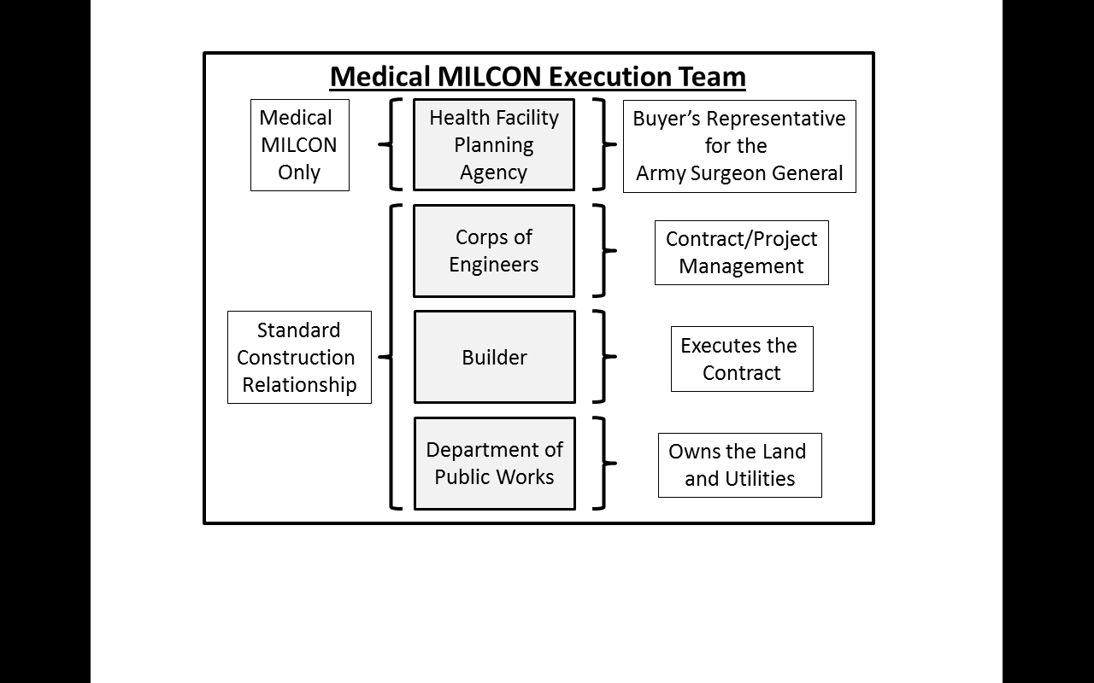

Figure , Medical MILCON Execution Team

Typically, MILCON projects require the cooperative efforts of the Corps of Engineers, the Department of Public Works and the contracted Builder. However, medical projects require a Buyer’s Representative to enforce cost controls and make medically technical decisions. Buyer’s representatives are required for medical projects because they are unusual and rarely experienced by regional COE districts.

**Photo Voltaic Power Generation:**

The DD form 1391 planning document set aside $10.34 million dollars for Sustainable Design & Development (SDD)/Energy Policy Act (EP Act). This money was specified for use in either water or energy conservation. Since the budget line item implies an effort to meet the gold standard for Leadership in Energy and Environmental Design (LEED) or at minimum achieve silver certification, the design team proposed solar power generation.

In order the explain LEED certification it is important to understand that the U.S. Green Building Council (USGBC) developed the voluntary environmentally sustainable building rating system, which is known as LEED. The USGBC is a non-profit trade organization that promotes sustainability in the design, construction and the operation of buildings. Many of the USGBC’s building principles are nationally championed by the U.S Environmental Protection Agency and since the EPA is supportive of USGBC environmental efforts, most federal building projects are now required to meet minimum LEED standards. As a consequence the MHS generally enforce LEED standards on all medical MILCON projects and usually require at least the silver rating.

LEED sustainability grades are based upon criteria that span five categories and include Sustainable Sites, Water Efficiency, Energy and Atmosphere, Materials and Resources, and Indoor Environmental Quality[24]. The criteria are used to provide a score based upon a 100 points system from which a LEED certification can be awarded. The certifications are awarded for the follow score ranges:

* Certified: 40–49 points
* Silver: 50–59 points
* Gold: 60–79 points
* Platinum: 80 points and above

Since the new hospital was planned for the desert, the design team determined that an energy conservation approach could be applied, with at least 30% of its electrical requirements provided through the use of photo voltaic power generation technology. This was great opportunity for the new Fort Irwin hospital to take advantage of its climate and location and have its own Photo Voltaic power generation capability. COE states that the solar power system is justified with an 18 year payback period[25]. This should be a good benefit for a facility that will have a 31 year minimal life expectance. The power generation technology funding is directly linked to the Sustainable Design & Development (SDD)/Energy Policy Act (EP Act) budget line.

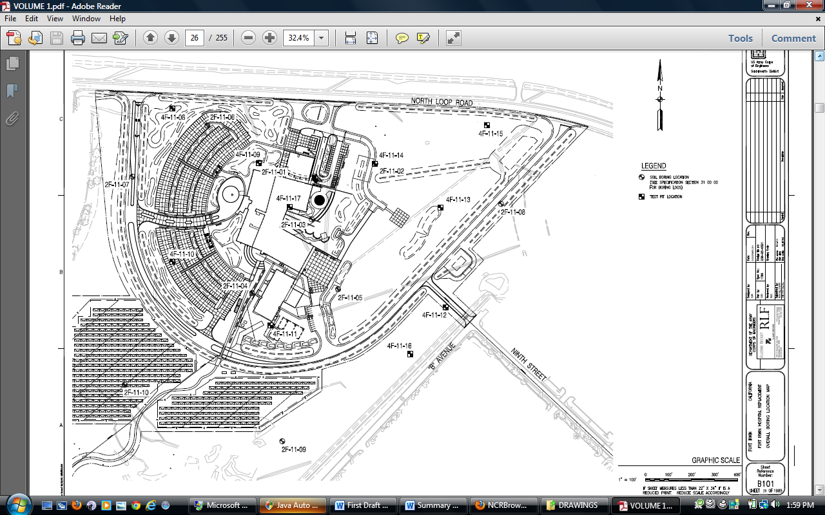

Photo Voltaic Cells

Figure , Hospital Photo Voltaic Site Layout, pasted from the Fort Irwin BID Documents package[26]

The Fort Irwin Hospital Replacement project DD form 1391 also includes a $3.5 million dollar LEED compliance requirement. The LEED budgetary line is used to support the funding of environmentally sustainable designs and is specified as part of the commissioning requirement. Like most MHS projects, LEED silver is the minimum requirement, but the Fort Irwin project was specified as having the goal of meeting LEED Gold. However, with the approved design including a Photo Voltaic power generation capability, it is believed that the new facility will achieve a Platinum rating. If LEED Platinum is achieved, the Fort Irwin hospital will be the second hospital in the world to meet that rating. The first hospital to achieve LEED Platinum rating is the DELL hospital in Austin, Texas.

**Evidence Based Design (EBD):**

EBD describes the healing environment and adapts the physical setting and the [organizational culture](http://en.wikipedia.org/wiki/Organizational_culture) to support [patients](http://en.wikipedia.org/wiki/Patient) and their families through the difficulties that are linked to illness, hospitalization, medical visits and sometimes bereavement. The new Fort Irwin Hospital EBD requires design features that may include:

* Hand holds and friction surfaces in patient restrooms.
* Design configuration of patient rooms.
* Special lighting fixtures and control setting capabilities.
* Design features which enable open spaces or exposure to peaceful natural environments.

Since there is no single list of EBD features, this design requirement is left to the imagination of the design team so long as there is an explanation of the planned feature which is linked to the budget line item.

**Adjusted Construction Costs:**

The Fort Irwin hospital replacement CIP was presented to the CIDM for a $326 million dollar projected amount. However, in the time since the project was selected for funding in 2010 to the current fiscal year, the total projected amount was reduced to $274 million dollars. The change in cost is a reflection of the change in the national business environment which is analyzed by the OMB. The OMB researches the average increase in cost to build a medical facility and calculates an annual cost escalation factor. The 2008 cost guidance based upon OMB analysis and approval by the Office of the Secretary of Defense (OSD) forecasted a 7% escalation factor for every year between FY11 to FY15[27]. Simple application of the escalation meant that for every year a medical project was delayed, a 7% increase in the overall price had to be planned. It is interesting to note that Kaiser Permanente used an 8% escalation factor during the same time period, which suggests that the government estimates were competitive with industry. Based upon the escalation factor and its use in the 2010 Program Objective Memorandum that was part of the President’s Budget and later passed into law, the Fort Irwin Hospital Replacement Project had a projected cost of $326 million dollars. Since the initial cost was assigned to the project, a number of revisions to the inflation guidance have been made. Latest cost guidance from OMB and OSD requires the use of 1.7 % and Fort Irwin’s project was probably reduced using a 1.8% rate which was specified in 2011. The current programmed amount is $274 million dollars for the new desert hospital. See Appendix B Inflation Guidance – FY2013 President’s Budget (Price Escalation Indices)

There are hundreds of planning considerations that must be met in order to justify, design and construct a medical facility. While only a few discussion points were examined in this study; those that were mentioned are unique to the planning of the Fort Irwin hospital replacement project.

**Timeline:**

It has taken three years for the Fort Irwin hospital replacement project to move from an identified medical requirement to the expected July 2012 ground breaking. The previous narration has thoroughly described the process and specified how the Fort Irwin project became a reality. Because of the nature of the Department of Defense budget process, there are few opportunities to shorten the timeline. The following is a Bar Chart which presents a list of planning milestones and mark the month of which they would occur.

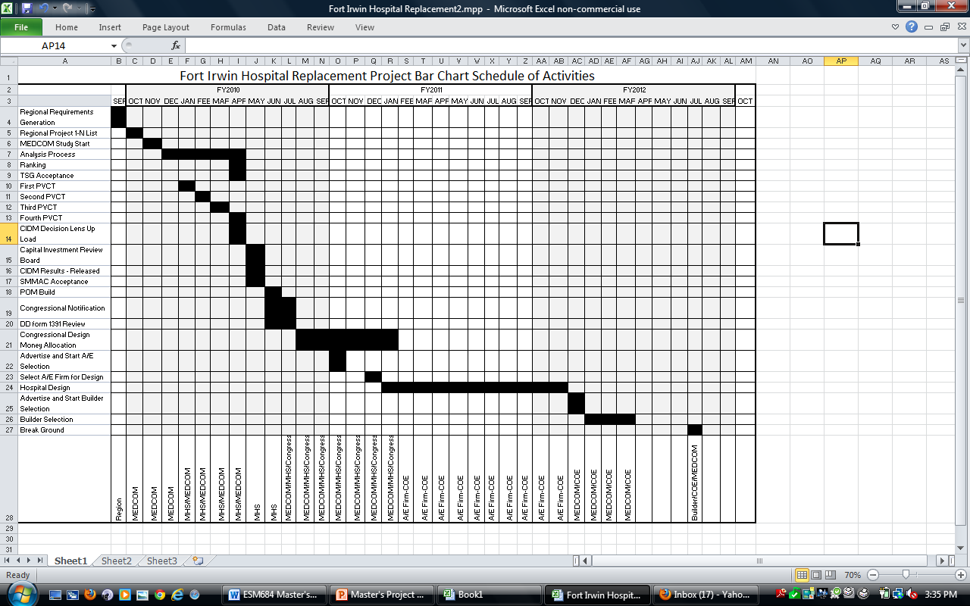

Figure , Project Bar Chart, This chart was developed specifically for this project.

The following is the actual CIDM schedule represented on a timeline. The timeline includes the activities that occurred from when the regions submitted their project lists to the release of the CIDM results. Microsoft Project was not used in the funding or selection process because suspense dates were perpetually left floating and often specific dates were not announced until only days before requirements were due. Regional requirements generation to TSG acceptance were scheduled within the management boundaries of the Army. From First PVCT to Advertise and Start A/E selection, the Office of Planning and Portfolio Management controlled the timeline. The following is the graphic timeline recorded after the CIDM.

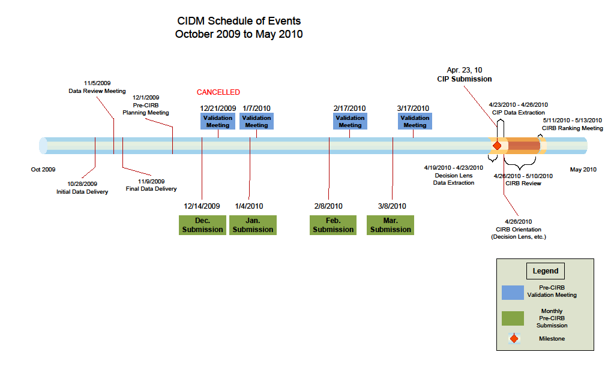

Figure , CIDM Schedule of Events, schedule dates were posted by the Office of Planning and Portfolio Management and the figure was developed for a briefing for the Army Surgeon General. [28]

Select A/E Firm to builder selection, the COE coordinated meeting dates and document turn-ins with the HFPA. From the time of Builder Selection to Ground Breaking, the builder will marshal their resources to comply with COE directed schedule.

**Process Improvement Recommendations:**

The following is a list of recommendations related to the MHS capital investment selection process. Discussion will include MHS and Army Scoring Criteria revisions, Diversifying cost reductions related to analysis, and acquisition strategy savings.

**Medical Scoring Revisions:**

Much of the expense in the capital decision making process can be attributed to the two scoring processes. The value of having an Army score card and then competing for MHS funding using another set of criteria is that Army projects will have under gone significant analysis and CSA imperatives will have been considered in the proposal. However the Army score card should be revised because the results consistently favor large installations over smaller posts and hospital projects over all other types of healthcare platforms, which is not similarly true in the MHS scoring system.

The Army score card supports larger complex medical projects because there is excessive emphasis on three sets of mission criteria. The mission 1 criteria awards points for the number of soldiers supported by the medical platform. Mission 2 grades projects based upon the number of services offered by a medical building project and mission 3 considers the number of Active Duty soldiers and their associated family members in the score. The three mission criteria in effect triple count what is nearly identical or at least very closely related criteria. This combined scoring can swing the closely related criteria from 15 to 45 percent of the overall score depending if a mission, facility or “equal” weighting is selected. So, even if only 15% of the scoring value is assigned for only one of ten criteria, then emphasis on the mission is significant for a criterion that does not directly correspond to any of the MHS score card metrics. Only the MHS’s subjective “Qualitative Assessment” criterion is somewhat aligned to the Army’s Mission criterion. This misalignment of Army and MHS scoring values potentially handicaps the Army’s CIPs when compared to the other services during CIDM.

To enhance the Army’s method, an adjustment should be made to its score card, which links MHS values to the Army scoring system. The below chart is a list of MHS criteria on the right and on the left side is the corresponding Army scoring criteria. The following are changes to the Army and MHS scoring criteria to better align project selection criteria:

* Army Facility Condition and Age and MHS Weighted Square Foot Age Improvements should be adjusted to match more closely.
* MHS should have a service mission criterion similar to the Army Mission Criterion. The Qualitative Assessment could be similar but is too subjective to be considered a matching mission criterion.
* At the time of these scoring charts, the Army was growing and there were capacity concerns. It is likely that options to reduce square foot inventory in the future will become more important. The Army should incorporate the MHS Percent Reduction in Square Footage Criteria in to its scorecard.
* AMEDD Utilization is supposed to assign value to building improvement projects that enhance co-location, adjacency and staff efficiency. This criterion should be dropped until the entire Army medical facility inventory has been modernized.

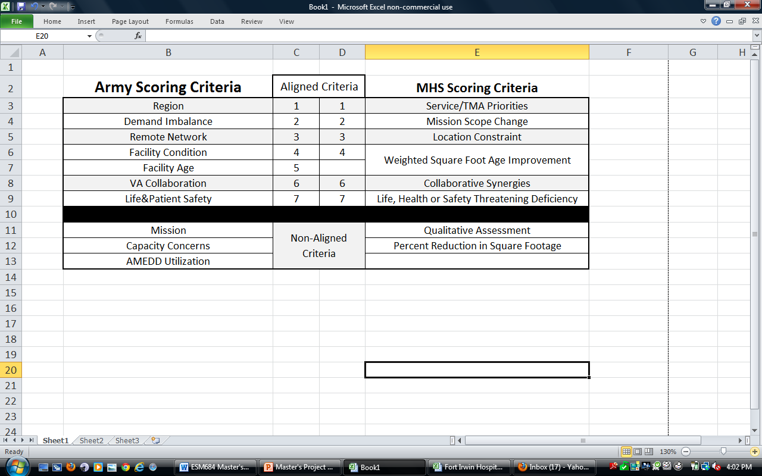

Figure , Army/MHS Criteria List, Compares Army Score criteria with MHS Score Criteria.

While there are many shared MHS and Army criteria, the meanings are not exactly the same and the MHS score card completely neglects the Army’s highest valued scoring criteria, Mission, which is directly linked to the number of beneficiaries and services provided by a medical platform or project. However, the Army should assign less emphasis on Capacity Concerns and AMEDD Utilization until all Army medical real property reaches the 31 year medical capitalization rate. If the Army adopts a criteria list that more closely resembles the MHS score card then fewer resources will be used to adapt Army CIPs into valid MHS proposals.

**Diversify Funding:**

In order to elevate the MHS investment in non-standard medical platforms an allocation of funding should be set aside to support the construction of veterinary clinics and Military Research Laboratories. Current, CIDM 1-N ranking analysis favors hospitals and large outpatient combined soldier family care clinics which results in those medical platforms receiving a disproportionately higher funding success. The reasons are not clear but could be because the MHS scoring criteria favors multi-care oriented medical platforms. This maybe because more hospital/clinic CIPs are generated by the three services or maybe among the services these medical platforms are in the greatest need of investment.

Based upon the POM created in 2010, only one veterinary clinic was funded out of more than 70 submissions and only two research laboratories were projected for funding in FY13 and 14. Since the veterinary clinics are exclusively Army treatment platforms and most military research facilities are unique Army responsibilities, accommodations should be made to at least guarantee minimal investments in each category. In order to establish some baseline level of funding emphasis on veterinary clinics and research laboratories, an application of Queueing Theory could be employed by using a combination of dollar value and timing as the queueing mechanism. Additionally, research laboratories usually cost hundreds of millions of dollars to build, and since no military service medical command desires research facility funding over a potential hospital replacement, phased and or incremental funding should be authorized to support a slow rate national military laboratory modernization program.

However, the underlying problem with the combined MHS investment system is that the three services emphasis different medical support characteristics. On one side of the investment spectrum are the Army projects that usually support a relatively small number of installations with populations of between 25 and 50 thousand soldiers, which therefor require large hospital investments. On the other side of the spectrum is the Air Force which utilizes a large number of small installations which usually only require clinic level investments. The Navy is a mix between the Army and the Air Force investment requirement because of its mixed support requirements to both Marine and Navy bases.

In the interest of saving money, it would probably be more efficient to not use the CIDM for selecting projects from a single Tri-service list. To save time and costs, the pre-CIDM funding allocation method should be adopted, but with one change. Instead of dividing up the budget in three equal parts, it might be better to develop a CIDM that measures each of the services total work load and modifies the work load numbers by the total condition index of the respective service. This kind of Tri-service based work load and facility condition analysis would likely reduce the intensive analysis required to compete individual projects. Another benefit to the services providing overarching medical analysis is that it would likely force the healthcare resource management staffs to get involved in developing work load numbers instead of requiring the facility management oriented staffs to secure, digest and present work load numbers to the MHS. If facility management expertise was focused on facility analysis and no MHS CIPs were required, then it would be unnecessary to hire outside design services, which are costly in time and money.

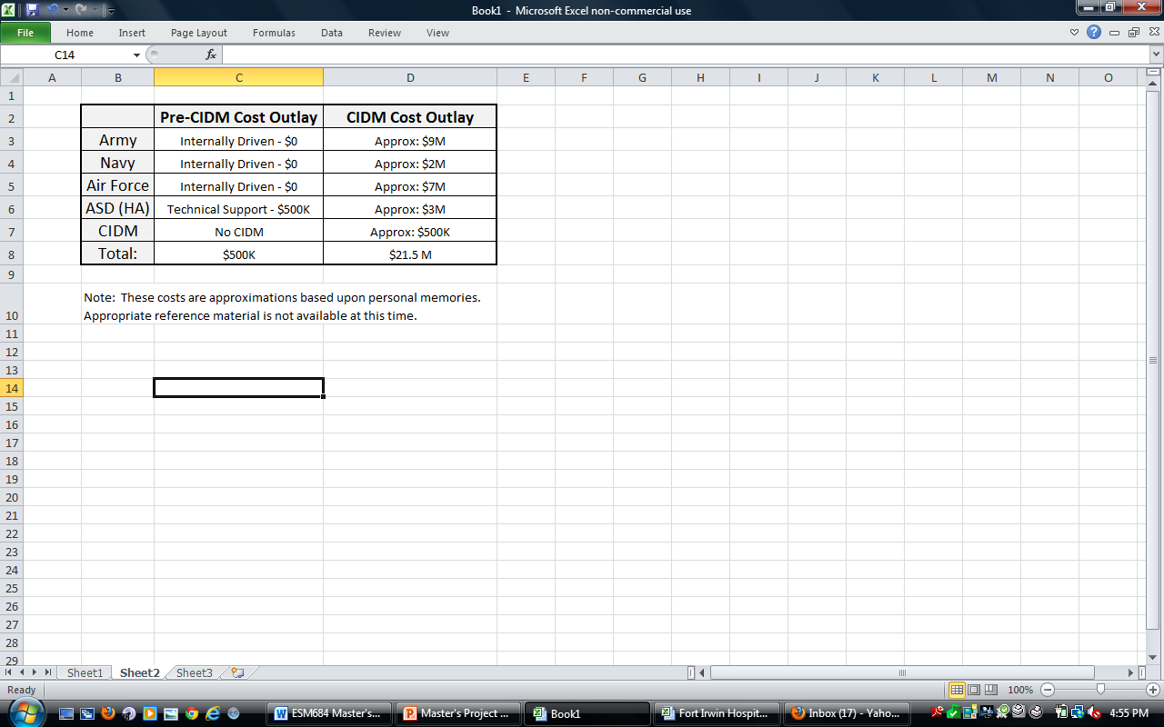

Figure , Cost Outlays Chart, actual cost estimates are based upon personal experience and the chart is provided to explain how cost saving could be achieved if Medical MILCON Decision making is decentralized.

**Design Build Acquisition:**

Traditionally, military projects use the Design Bid Build Acquisition strategy which usually requires more time to execute than what is usually required by Design Build.

The contrast between DBB and DB build is as follows:

DBB DB

13% standard design cost[29] 6% standard design cost

2 bid selection phases 1 bid selection phase

*CMAR is not presented because no MHS cost guidance has been published; but some saving in time compared to DBB would be expected.

Design build should cost less and require less time to allocated funding, which means more efficient use of resources. Additionally, it can be possible to take advantage of unusual funding opportunities. For example, the 2010 POM prepared the project funding schedule for 2012 to 2017, however when the Fort Irwin Project was moved to the ARRA 2009 funding source, it might have been better to execute the project using design build. The timesaving associated with design build might have enabled a nearly one year earlier start and the project’s design costs would have been lower. The 7% reduction in design costs on the project could have saved as much as $15 million dollars and a one year earlier construction start might have saved another 1.8% in the price escalation factor; the equivalent of $5million dollars. The combined total cost savings to the Fort Irwin hospital replacement project if design build has been used could have been nearly $20 million dollars.

**Summary Recommendation:**

Major changes should be made to the Military Capital Investment Process.

The first change should be the re-delegation of capital investment funding to the services because the MHS’s centralized control is costing as much as $21.5 million dollars a year or the equivalent of 7% of the MHS MILCON budget in contracted design support. The contracted design support money should be spent on actual capital investment or sustainment support rather than centralized decision making process.

Another recommendation is that capital investment funding should be distributed as a percentage to each service based upon the combining of medical work load and overall facility conditions. The idea is to fund the services proportionate to the amount of healthcare performed and to level service wide infrastructure investment necessary to modernize the overall MHS facility inventory.

Considerations should be given to ensure funding for military research laboratories and Army veterinary clinics. A simple budgetary solution would be to establish a separate allocation of funds apart from standard medical MILCON, for the purpose of investing in laboratory and veterinary clinic modernization.

Finally, whenever appropriate, the design build acquisition strategy should be utilized in order to save, 7% of the program amount on design costs. A single contractor selection process reduces some management burden on the military facility management team and supports opportunities for early funding.

**Appendix A: DD form 1391 Fort Irwin, California; Hospital Replacement**

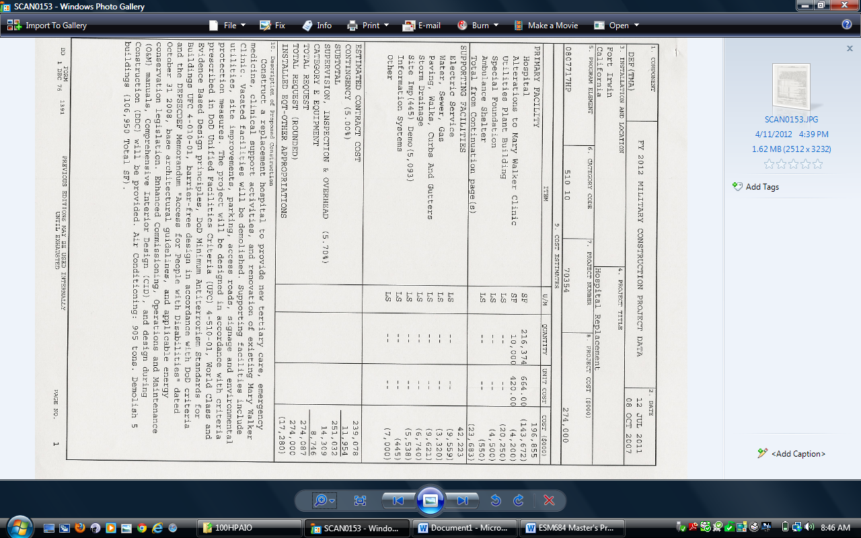

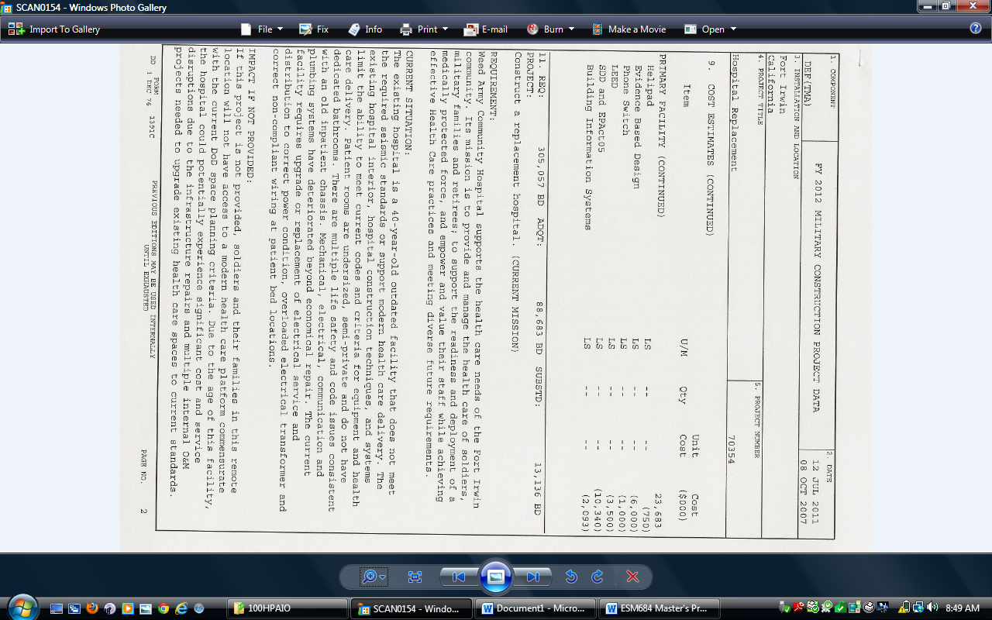

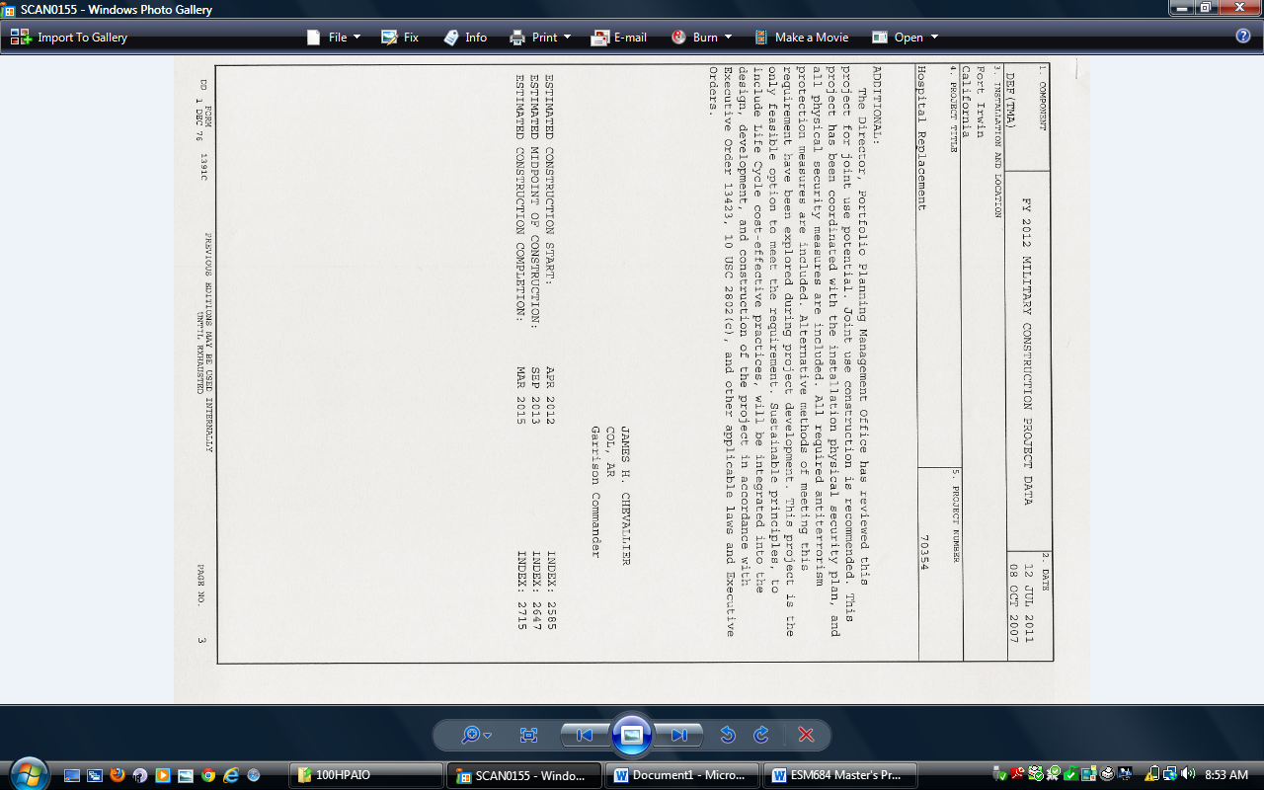

**Appendix B: Inflation Guidance – FY 2013 President’s Budget (Price Escalation Indices**

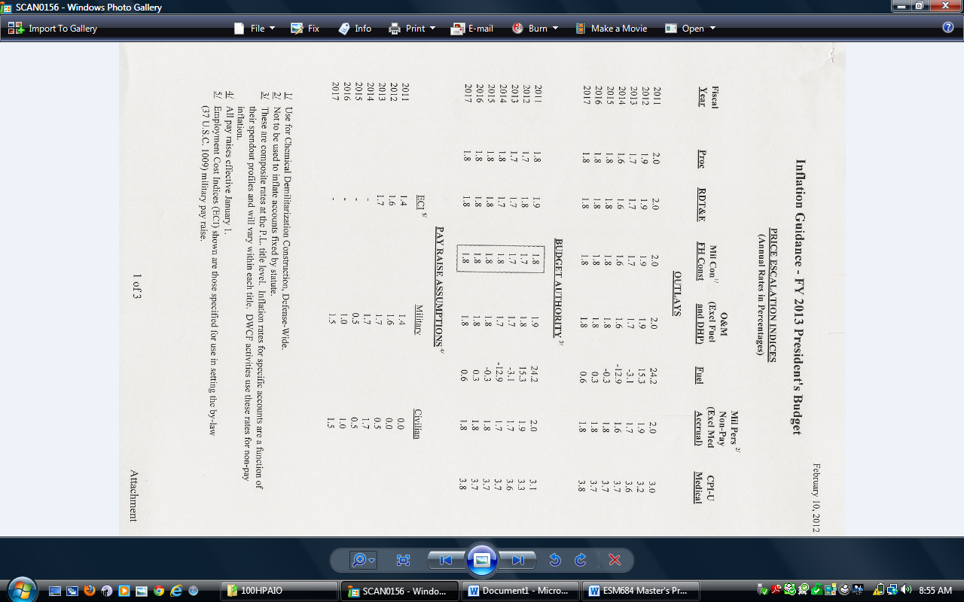

**Reference: Endnotes List**

1. U.S. Department of Defense, “DoD 101, An Introduction Overview of the Department of Defense,” <http://www.defenselink.mil/pubs/dod101/> (accessed April10, 2012)
2. <http://www.defense.gov/about/dod101.aspx#bottomline> (accessed April 23, 2012)

   “U.S. Department of Defense Fiscal Year 2013 Budget Request Overview,” (2013), page 5-2 http://comptroller.defense.gov/defbudget/fy2013/FY2013_Budget_Request_Overview_Book.pdf (accessed April 23, 2012)
3. “U.S. Department of Veterans Affairs Fiscal Year 2013 Budget Submission Summary Volume,” (2013) page 2, http://www.whitehouse.gov/sites/default/files/omb/budget/fy2013/assets/vet.pdf

   (accessed April 23, 2012)
4. Priest, Dana &Hull, Anne, “Soldiers Face Neglect, Frustration At Army’s Top Medical Facility,” [http://www.washingtonpost.com/wp-dyn/content/article/2007/02/17/AR2007021701172.html February 18](http://www.washingtonpost.com/wp-dyn/content/article/2007/02/17/AR2007021701172.html%20February%2018), 2007, (accessed April 10, 2012)
5. “ Government Accountability Office (GOA), GAO-09-801T, “Federal Real Property, An Update on High Risk Issues,” Washington, D.C., July 15,2009, http://www.gao.gov/products/GAO-09-801T, (accessed April 12,2012).
6. “U.S. Department of Veterans Affairs Fiscal Year 2013 Budget Submission Summary Volume,” (2013) page 2, http://www.whitehouse.gov/sites/default/files/omb/budget/fy2013/assets/vet.pdf

   (accessed April 23, 2012)
7. Flanagin, Michele. Overview of Kaiser Permanente National Facility Services, delivered to TEAM ARMY November 2008
8. Percentage attributed to LTC Schoolmaker, Army Surgeon General, during April 2010 medical MILCON decision briefing
9. ACSFAC PPD 2010 MEGA POM, project tracking document
10. Ibid
11. Ibid
12. Ibid
13. Ibid
14. 2008 Army Poster Statement, Two Critical Challenges: Restoring Balance and Funding, <http://www.army.mil/aps/08/critical_challenges/critical_challenges.html> (accessed April 10, 2012)
15. Attributed to COL Richard Bond, Commander, United States Army Health Facility Planning Agency, retirement speech, June 2009
16. Kroll, Karen. “Evidence Based Design in Healthcare Facilities,” January 2005, [http://www.facilitiesnet.com/healthcarefacilities/article/Better-Health-From_Better-Design--2425#](http://www.facilitiesnet.com/healthcarefacilities/article/Better-Health-From_Better-Design--2425) (Accessed April 10, 2012)
17. Dunbar, Bradley. Army MEDCOM Capital Investment Prioritization, Briefing to TSG, April 9, 2010
18. Ibid
19. Ibid
20. Facility Master Plan Update Final: June 2005. Weed Army Community Hospital, Fort Irwin California, prepared by the Smithgroup and The Innova Group
21. Ibid
22. Ibid
23. Ibid
24. U. S. Green Building Council, <http://www.usgbc.org/> (Accessed April 10, 2012)
25. Walrath, Bryan.(Weed Army Community Hospital Replacement Project, Program Manager), Email: Minutes of Meeting with HFPA and SPL, 8 Feb. 2012, February 20, 2012
26. Fort Irwin BID Documents/Drawings & Specs (FINAL), December 2011
27. Hale, Robert, “Inflation Guidance – Fiscal Year (FY) 2013 President’s Budget” Office of the Under Secretary of Defense, February 10, 2012
28. Dunbar, Bradley. Army MEDCOM Capital Investment Prioritization, Briefing to TSG, April 9, 2010
29. TMA DD 1391 Cost Estimating Guidance For Medical Project, March 24, 2008